## Evaluation of Boomlift Carried Environmental Enclosure (BCEE)

**Subcontract Number: 2016-429**

*Approved for Public Release. Distribution is unlimited. Category B Data – Government Purpose Rights*

**Executive Summary**

The NSRP Environmental and Surface Preparation and Coatings Panels endorsed this project.

Airless spray paint remains the most common and most effective application technology for large surface coatings in shipyards. However, airless spray painting generates unacceptable levels of paint overspray. Overspray, as fugitive particles landing about the shipyard and parking lots is an undesirable irritant and expense. In addition, anti-fouling overspray can find its way through direct deposition or through run-off, into the surface waters adjacent to the shipyard.

The Boomlift Carried Environmental Enclosure (BCEE) is an advanced lightweight boomlift-carried paint overspray capture system. It is the result of many iterations of similar devices that have been designed over the years but never implemented by the industry.

The project team built, delivered and conducted shipyard trials with two units. The first unit underwent beta testing at BAE Systems Jacksonville Ship Repair (JSR). Engineering and field test were run and evaluated. Multiple airless spray operations were conducted on ships in dock. Feedback from the beta testing was built into Unit 2.

Unit 2 included a training module that allows the operator to practice maintaining the proper standoff distance without the BCEE in the hi-reach. This feature proved beneficial in getting new operators acclimated to the process.

Over the last 4 months, successful shipyard trials were accomplished with Unit 1 in BAE Systems (JSR) (Jacksonville FL) and unit 2 at GD-NASSCO (San Diego, CA) and GD-BIW (Bath, ME).

The project team trained employees on installation and operational procedures of the BCEE. The BCEE was deployed by boomlift to the hull/freeboards of ships in dry dock where production spray outs were accomplished. Time study comparing open-air spray against the capture device were accomplished when possible. Typical airless spray times were compared against the BCEE application. .

Cost evaluation of the BCEE vs containment costs are site specific. It will require a yard to compare their containment cost by size and location in their yard against a 30% increase in airless spray time and the cost of the BCEE to develop a site specific ROI.

# Table of Contents

Table of Contents 3

List of Figures 4

Background 5

Implemented Project Goals 5

System Description 7

Design 7

History of Portable Overspray Capture Devices 10

Spider E-Tank 10

APACTS 10

SAPOCS 11

MAEE 12

Review of Past Related Work 14

Capture Efficiency Measurement 14

Required Shipyard Services 17

Demonstrations and Modifications 18

BAE Jacksonville 18

General Dynamics – National Steel and Shipbuilding Company 21

General Dynamics – Bath Iron Works 22

Mid-Program Modifications 23

Results 28

Project Participants 29

References 30

# List of Figures

Figure 1 Boomlift Carried Environmental Enclosure (BCEE) 7

Figure 2 Spider E-Tank, (sketch from patent) 10

Figure 3 Automated Paint Application, Containment, and Treatment System 11

Figure 4 SAPOCS Approaching Surface and with Test Paint Swath 12

Figure 5 MAEE version 2 at Atlantic Marine (left) and version 3 at General Ship in Baltimore (right) 12

Figure 6 MAEE version 4 (left) and version 6 (right) 13

Figure 7 MAEE version 7 at O. T. Neighoff Industrial Painters 13

Figure 8 Overspray Image 14

Figure 9 Blotter Mount (left), Sample Blotter without Seal (#1), Sample Blotter with Seal (#6) 14

Figure 10 Pixel Sums at 6" and 8", Port and Stbd Sides, Seal On and Off 16

Figure 11 Results with Maritime Coatings 16

Figure 12 BCEE along a DDG at BAE Systems JSR 18

Figure 13 Painting of the Ranger Not Export Controlled per PS-2018-DR-469 19

Figure 14 Painting of the Ranger Not Export Controlled per PS-2018-DR-469 20

Figure 15 BCEE Painting a MegaYacht Not Export Controlled per PS-2018-DR-469 21

Figure 18 BCEE in a Genie S-65 alongside USNS Miquel Keith 22

# Background

Shipyards have many techniques to apply coatings. Each method enjoys advantages and disadvantages. The production advantages of airless sprayers have been known for decades [NSRP]. An airless sprayer can paint 8-12,000 ft2 per shift while the same painter with a roller paints only 2-4,000 ft2. The airless sprayer’s disadvantage is the overspray. Overspray is the undesirable discharge of paint particles into the environment. These particles pose risks to personnel health and to the environmental. The EPA limits overspray through the National Emission Standard for Hazardous Air Pollutants (NESHAP). The risks and limits have encouraged the development of many overspray capture devices through the years. These range from a simple manual rigs through highly automated remotely operated systems. Meanwhile, shrink-wrap and tarp systems have become the common containment systems in shipyards. However, the overspray is not captured in these systems, only contained. Without capture, the surface waters ultimately receive the residual overspray.

This project intends to prove the performance value of a prototype overspray capture device through shipyard demonstrations and use. The Boomlift Carried Environmental Enclosure (BCEE) is a lightweight advanced boomlift-portable paint overspray capture system. In this project, the project team implements two BCEE units. The first BCEE travels to a shipyard for initial evaluation. The second unit travels to as many shipyards as funding allows gathering continued use data, compliment production needs, assess ease-of-use, and identifying worker preferences and objections.

## Implemented Project Goals

Shipyard employees will be instructed on installation and operational procedures of the BCEE. A time study comparing open airless spray painting against the BCEE capture device airless spray-painting was completed. An ROI template that can be applied to the site specific; containment costs, application rates, environmental concerns and schedule benefits to the shipbuilding and repair yards was provided

Task 1: 1st Shipyard Training and Beta testing: The Project Engineering team demonstrated the prototype BCEE at BAE Systems JSR. The initial demonstration was conducted over a period of approximately four days and included operational and safety training for the shipyard personnel. Beta testing was conducted on a non- production surface.

Task 2: BCEE Prototype Modification: Project Engineer team shall make all modifications to existing Unit 1 BCEE prototype and constructed Unit 2 BCEE combining proven technology, lessons learned.

Task 3: Prolonged Shipyard Use: Unit 1 BCEE was put into production at BAE Systems JSR. The shipyard performed appropriate production and effectiveness studies.

Task 4a: 2nd Shipyard Trial: Project team demonstrated the BCEE at a second shipyard West Coast, GD-NASSCO San Diego. The trials included appropriate operational and safety training for the shipyard personnel and a production spray out on the freeboard of a ship in dry dock.

Task4b: 3rd Shipyard Trial: Outside of the original scope of the project Unit 2 was shipped to GD-BIW where a third trial was conducted. The trials included appropriate operational and safety training for the shipyard personnel and a production spray out of freeboard of a ship in the building ways.

Task 5a: Task 5a: Technology Transfer: The BCEE was showcased at NSRP Surface Preparation and Coating / Environmental panel meetings, NSRP Day at NAVSEA and the final report was presented at Mega Rust May 2018.

# System Description

The BCEE (figure 1) is an overspray capture device for large relatively flat surfaces such as ship hulls, storage tanks and some metal and concrete buildings. The BCEE consists of a base and an enclosure. The base rides on the deck of a boomlift’s basket, carries the enclosure, and tilts the enclosure to align with the surface to be painted. The enclosure is a 6’ by 8’ by 2’ box that projects over the front of the boomlift basket. The enclosure has a small opening in the back (to give access to a painter), a large opening along the surface (to apply paint), pneumatic seals about the openings, blowers to draw air from the enclosure and supply the pneumatic seals, and filters to trap overspray before the overspray can escape into the environment.

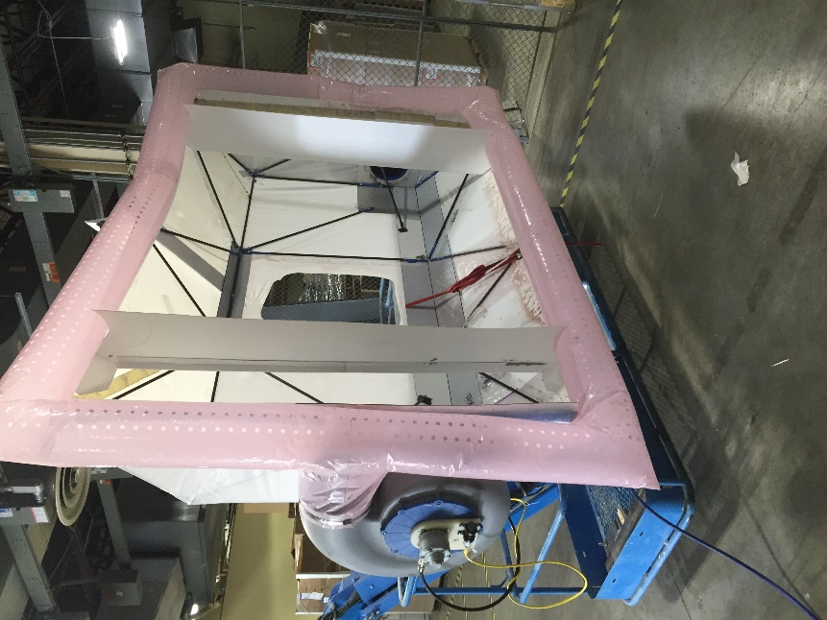

Figure Boomlift Carried Environmental Enclosure (BCEE)

## Design

The BCEE consists of a perforated plenum along the periphery of an enclosure that is carried on a frame that, in turn, is carried in boomlift’s basket. The BCEE has three primary design considerations; capture efficiency, weight, and meeting OSHA requirements. OSHA regulations encourage, and in some cases require, a boomlift’s manufacturer to certify that a boomlift is as safe with a unique use as the boomlift was before the unique use. The weight goal is a combination of the common boomlift design and shipyard preferences. The capture efficiency is dictated by the available performance of the overspray capture filters.

Under 29 C.F.R 1910.67(b)(2), OSHA requires all field modifications of an aerial lift be certified by the manufacturer to be as safe with the modification as without the modification. This regulation has been informally extended to unique uses of a boomlift. ANSI/SIA A92.5 defines the safe construction of a boomlift and specifies a number of required stability tests. These tests specify the carried load and the load distribution. In accordance with these tests, the BCEE’s Center-of-Gravity (CoG) is at least 12” behind the basket’s forward kick plate and not more than 12” above the basket deck. Due to the hose’s length and position, the hose is a significant contributor to the CoG and the BCEE should not be carried aloft without a hose.

Many boom-style aerial lifts have a general unrestricted-reach capacity and a larger (up to double) restricted-reach capacity. The BCEE predecessors were designed to comply with the restricted-reach capacity. However, during tests, shipyards expressed a reluctance to use a device that could not be carried throughout the full reach of the boomlift. Thus, the BCEE was redesigned to weigh about 190 lbs. so that, with a 40 lbs hose, a least half of unrestricted-reach capacity (250 lbs) remains available for the operator.

The BCEE seeks to match the maximum capture efficiency of available filters. The nominal capture efficiency of a 2-inch polyester tackified paint booth filter is 95%. Thus, the BCEE is designed to achieve capture 95% of the overspray. The BCEE captures by entraining the overspray into an airflow from a peripheral seal. To achieve a high capture efficiency, the enclosure must be parallel with the surface and the standoff between the enclosure and the painted surface should be approximately 4” and not more than 6”. The enclosure must pitch and yaw to make the enclosure parallel to the surface. The boomlift provides the yaw and the mounting frame tilts to provide pitch. Since the required standoff is relatively small compared to the motion of a boomlift, sensors are mounted on the enclosure to inform the operator of the current standoff.

### Enclosure

The BCEE enclosure protrudes over the front of the boomlift basket and carries the blowers, filters, sensors, and the seal plenums. The blowers weigh approximately 25 lbs each while the total enclosure weight is 80 lbs. To achieve this weight, the enclosure frame is an assemblage of pultruded carbon composite rods, an aluminum/plastic composite back, and aluminum blower and tilt mount plates. The enclosure is covered with polyethylene (marine wrap) skin that must be periodically replaced. The BCEE’s enclosure concept was patented in 2013 [Norcross].

The blowers mount on the enclosure’s sides, draw from within the enclosure, and exhaust into the seals. The filters mount within the enclosure in front of blower intakes. Polyethylene baffles on composite rods mount to the front edge of the enclosure to limit the painter’s tendency to discharge directly into the seal or filter.

### Tilt Frame

The tilt frame carries and tilts the enclosure. The frame fits in the boomlift basket and holds the enclosure over the front of the basket. The frame consists of a pair of legs (vertical members) and feet (the horizontal members). The back tilt force is provided by gas springs and the forward tilt force is provided by a cable attached via pulleys to a linear actuator in the foot.

The nominal dimensions of a typical boomlift basket is 8’ wide by 3’ deep by 45” high. The basket railings reduce the area slightly. Therefore, the BCEE frame is 33” deep by 72” wide by 47” high.

The foot is a metal tube that lies on the basket deck between the leg and a counterweight. The foot contains the tilt actuator and a turnbuckle eye nut to adjust the length of the tilt cable such that the tilt arm is horizontal when the actuator is fully retracted. The leg stands vertically at the front of the basket. A bar at the top of the leg positions the pivot point several inches behind the enclosure. The Tilt Arm extends from the pivot to the enclosure. The gas spring and cable apply forces to the arm to make the enclosure tilt.

### Seal

The seal is formed by the airflow through a perforated 24” circumference tube that is mounted circumferentially about the BCEE’s enclosure [Hertel]. The minimum flow through the perforations to achieve a seal at 4” was determined to be 2400 fpm.

The seal tube’s design expels about one third of the filtered air, which insures a net inflow through the access window. However, a net inflow does not prevent a periodic outflow. Thus, the window is surrounded with a smaller perforated tube that insures a continual inflow. Since the window tube is not intended to “seal”, the flow from the window tube may be slower than from the periphery tube.

Two 10-inch blowers, each powered by a 1.7 hp air motor, power the seals. A single 1”, 90-psi air line is sufficient to drive the two blower motors. However, in some shipyards, due to other air demands, only 70-psi lines were available at the dry dock or pier. In these situations, a pair of 70-psi airlines provide sufficient flow. [ONR]

# History of Portable Overspray Capture Devices

## Spider E-Tank

In the mid-1990’s Interstate Coatings of Seattle, WA patented a “Spray Containment and Enclosure Assembly” [Kane]. The enclosure was “for use during the spraying operation on a work surface to prevent escape of airborne particles to the environment.”[Kane] Flow International commercialized the invention as the Spider Environmental Tank (E-Tank).

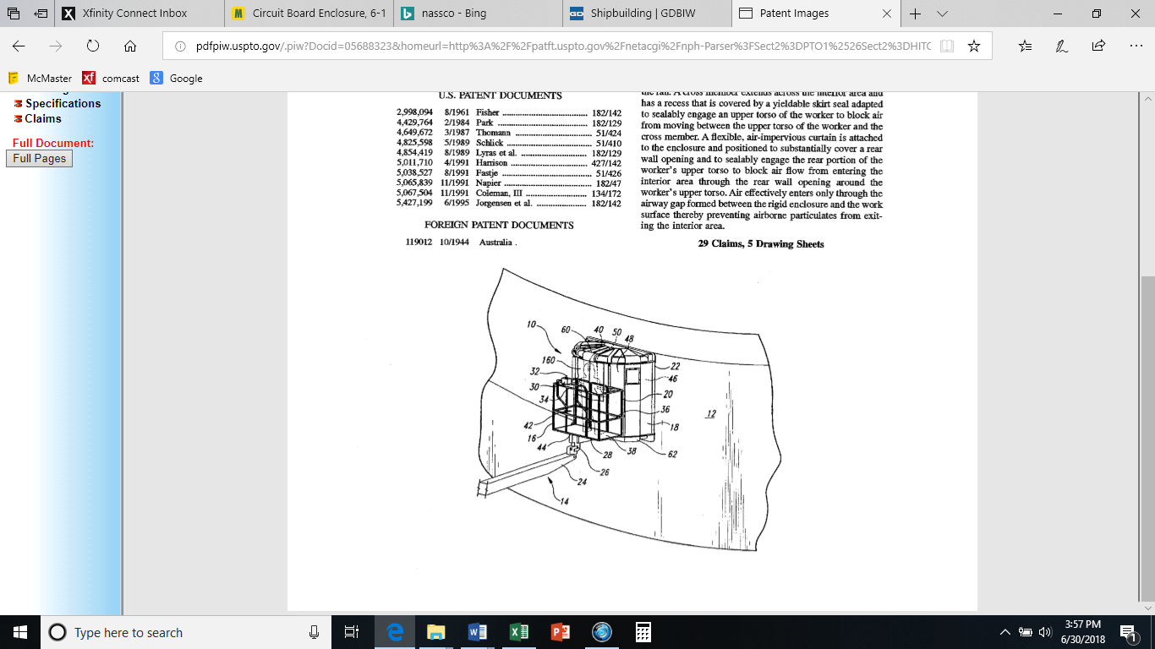 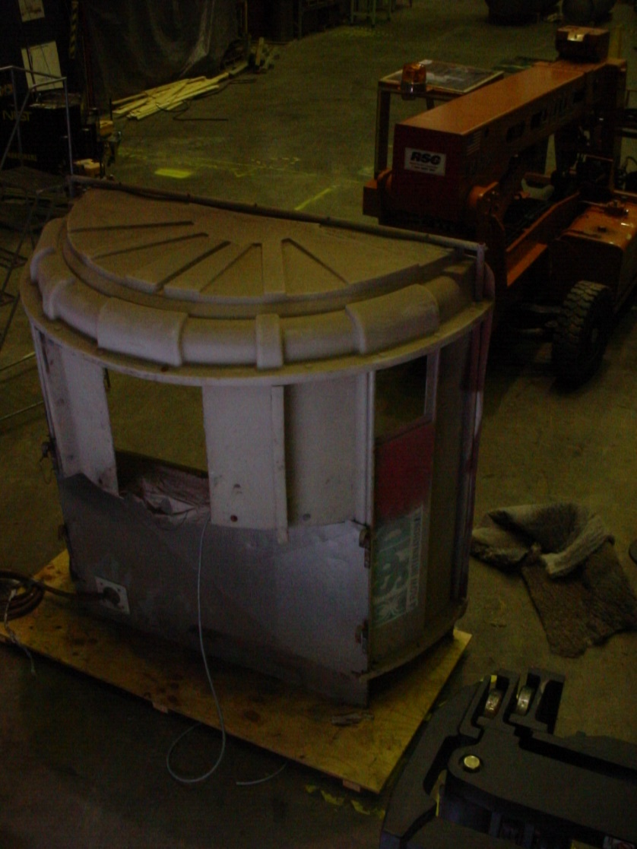

Figure Spider E-Tank, (sketch from patent)

The E-Tank included a heavy plastic shell, a pneumatic-powered fan that pulled overspray laden air through a filter, and a skirt and curtain to enclose the upper torso of the painter inside the shell. The device had three notable shortcomings. First, the fan could only provide sufficient flow to entrain the overspray when the painter enclosed himself inside the enclosure. When the painter failed to properly engage the enclosure’s skirt and curtain, much of the overspray would escape. Second, the device relied on negative air pressure and a narrow gap between the device and the painted surface. If the painter set up too narrow of a gap, the negative air pressure could draw the enclosure into contact with the surface. If the painter’s gap was too great, much of the overspray would escape. Third, the device weighed approximately 400 lbs with a center-of-gravity about 14 inches in front of the basket. Aerial work platform standards determine stability when the center of gravity is 12 inches inside the basket [ANSI]. Thus, the system could only be used in the restricted reach zones of larger boomlifts.

## APACTS

In 1997, the Naval Surface Warfare Center (NSWC) Carderock Division began development on the Automated Paint Application, Capture, and Treatment System (APACTS). By 2002, Oceaneering International, Inc. (OII) had constructed a prototype APACTS [OPNAV]. APACTS coordinated the motions of the boomlift’s actuators and replaced the boomlift’s basket with a spherical robot carrying a paint head and containment shroud. The coordinated actuators moved the robot coarsely along the surface while the robot simultaneously moved the paint head along a fine paint trajectory and the shroud vacuumed the overspray down to a separate treatment system on the ground level. APACTS proved to be too expensive to be economically viable.

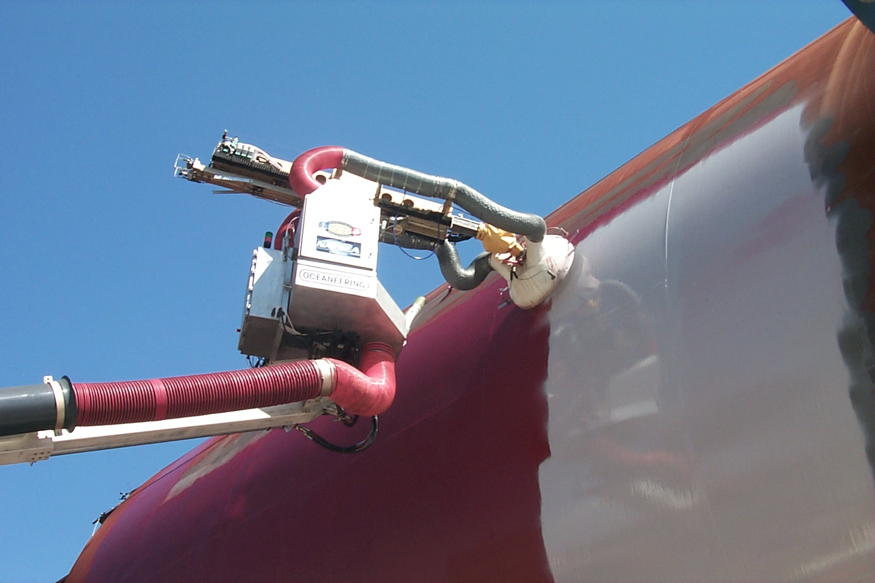

Figure Automated Paint Application, Containment, and Treatment System

## SAPOCS

In 2002, the Office of Naval Research sought a more economical solution by combining the Spider E-Tank with APACT’s coordinated boomlift motion. The Semi-Autonomous Paint Overspray Containment System (SAPOCS) mounted an E-Tank onto a boomlift that had been used in the development of the boomlift coordinated motion for APACTS. SAPOCS was demonstrated at Atlantic Marine in late 2002. SAPOCS was able to maintain a more consistent standoff than the E-Tank, but suffered many of the E-Tank’s limitations.

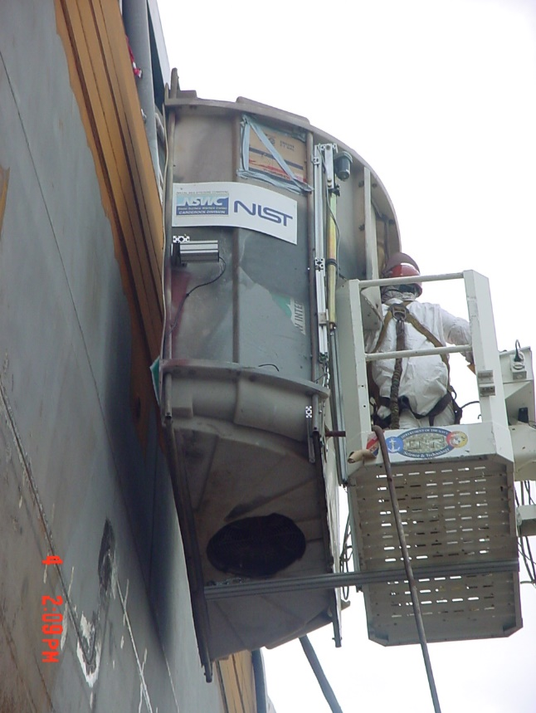 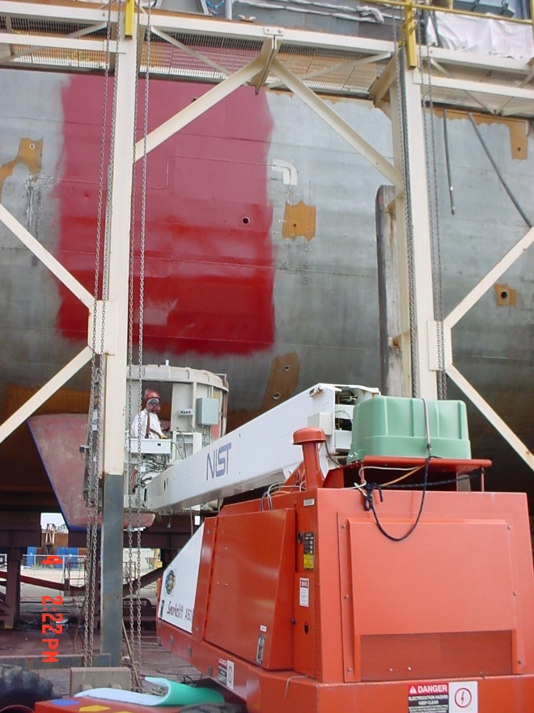

Figure SAPOCS Approaching Surface and with Test Paint Swath

## MAEE

The Motion Assisted Environmental Enclosure (MAEE) program was a sequence of devices that preserved much of the SAPOCS’ semi-autonomous motion while improving the overspray capture and complying with the OSHA’s OEM certification requirement. Each MAEE iteration reduced the system’s weight while improving the system’s weight distribution, reliability and capture efficiency. Although the boomlift OEM certified the system for development, they declined to certify MAEE for commercial use. The following figures show some of the evolution of the MAEE system. The seal from MAEE version 7 (Figure 7) is currently used in the BCEE system.

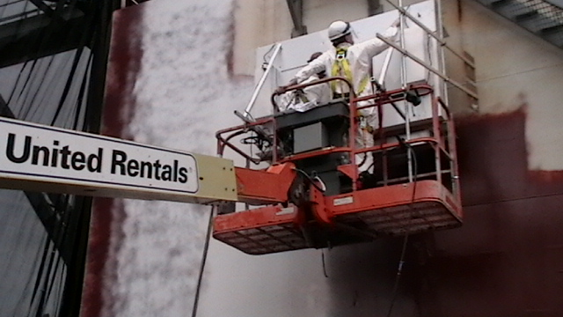 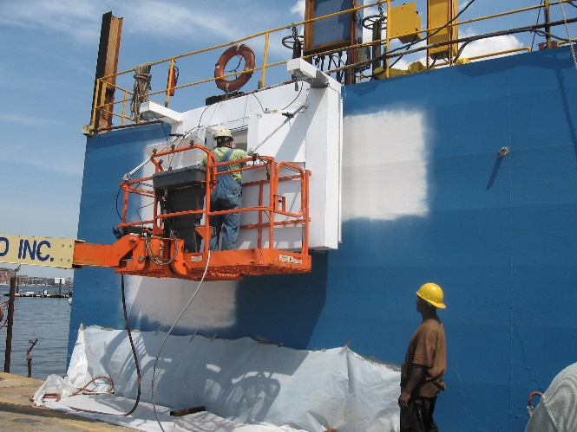

Figure MAEE version 2 at Atlantic Marine (left) and version 3 at General Ship in Baltimore (right)

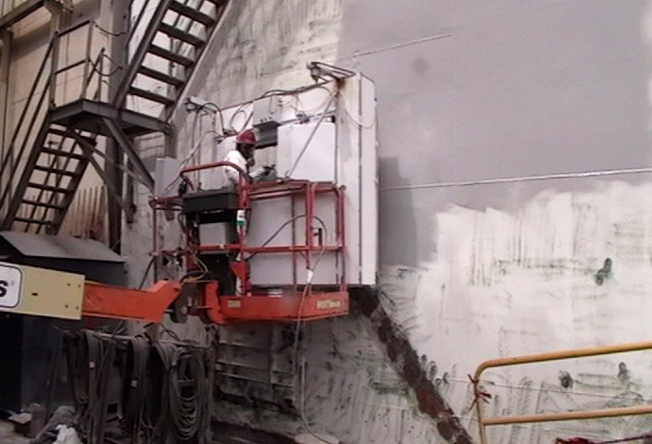 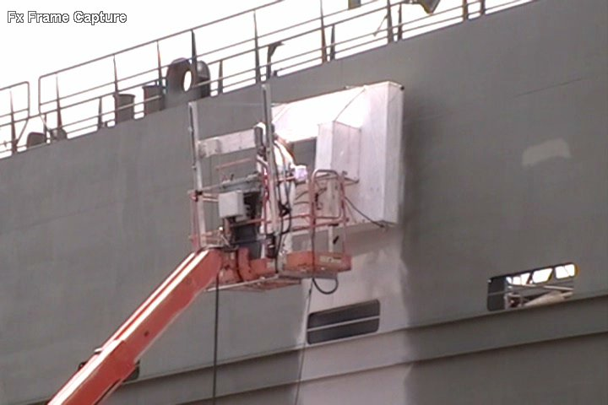

Figure MAEE version 4 (left) and version 6 (right)

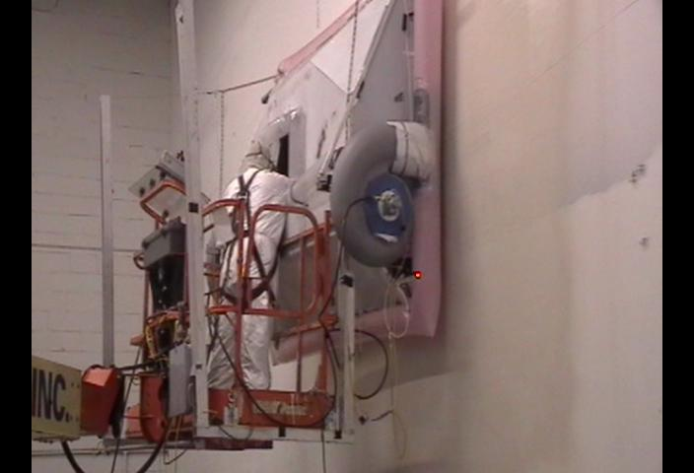

Figure MAEE version 7 at O. T. Neighoff Industrial Painters

# Review of Past Related Work

## Capture Efficiency Measurement

The BCEE’s capture efficiency was determined through stationary blotter tests. The tests demonstrated that the capture efficiency met or exceeded the published capture efficiently for readily available paint booth filters.

### Measurement Method

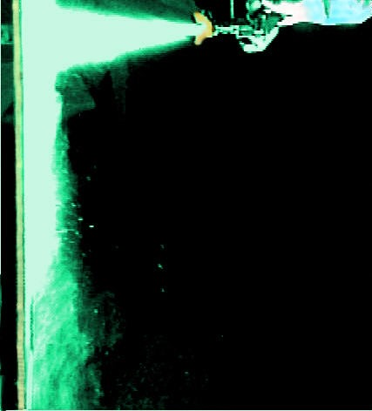

Figure Overspray Image

The capture efficiency test is a volumetric comparison of the overspray leaving a paint area with and without the BCEE’s pneumatic seal. In fluid dynamics terms, overspray is a “wall-jet” flow [Glauert] modeled by a “strong current of particles mov(ing) outward along the wall in the ±x-direction” [Settles] from the impingement point. We mount plain white paper blotters in the overspray’s primary direction just outside of the seal. The escaping overspray collects on blotters speckling the blotter surface. The area and darkness of the speckled surface is proportional to the volume of paint exiting the area. We perform a greyscale scan of the blotters and use computer software to sum the readings in the center area of the blotter. Since the scan measures the blotter darkness, even an unused blotter returns a value and that value is subtracted from the readings. The capture efficiency is therefore computed by:

$$Capture Efficiency=1-\frac{BlotterWithSeal-BlankBlotter}{BlotterWithoutSeal-BlankBlotter}$$

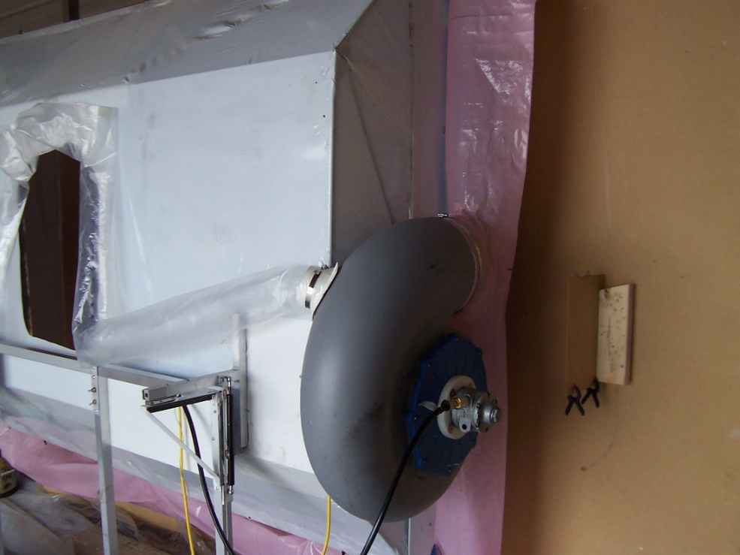

Figure Blotter Mount (left), Sample Blotter without Seal (#1), Sample Blotter with Seal (#6)

A comparison measurement requires that conditions other than the element being measured be held constant. Therefore, the capture efficiency measurement is a stationary test. That is, the BCEE is not carried in a boomlift, but rests on a surface in front of a target surface. Furthermore, the painter must repeat the paint application pattern (standoff, speed, stroke, etc.) for each sample. Such requirements generate significant noise and only the median values are used in the computations. Due to the repetitive requirements, the measurement values represent a best result.

### Results

Extensive tests of the blotter where conductor for the Office of Naval Research (Code 332) under contract N00014-12-M-0347 and NSWC-CD.

The figures below are logarithmic box plots of the offset pixel summation (i.e., the value minus the median value of the blank blotter). Therefore, the ratio of the seal on and seal off values is the capture efficiency. Each tick line difference represents a factor of ten; one tick line is 90% capture, two tick lines is 99% capture.

#### General Coatings

Figure 10 shows the capture results at 6” and 8” and from the Port and Starboard sides of the enclosure. The two conclusions from this data is the handiness of the painter and that the seal diminishes beyond about 6” from the surface. Both problems can be avoided with training.

The “handiness of the painter” means that the painter generates more overspray in one direction than the other. Although collected at the same time, the starboard baseline was four times the port baseline. Similarly, the BCEE captured 98% on the port side but only 90% on the starboard side. The difference is the result of painter technique, particularly feathering near the enclosure seal. Direct discharge from a spray gun easily overwhelms the BCEE’s seal. Likewise, direct spray discharge into the filters overwhelms the filter. Following this test, baffles were added to guard against these errant discharges.

The BCEE seal is designed to operate around 4”. The amount of flow to effect a seal rises exponentially with the distance from the surface. The 8” test showed only 34% capture. Therefore, the operator must be trained to keep the BCEE between 2” and 6” from the surface. As will be discussed in subsequent sections, such standoffs are achievable when approaching with the boomlift’s lift and extend joints.

Figure Pixel Sums at 6" and 8", Port and Stbd Sides, Seal On and Off

#### Marine Coatings

Figure 11 displays the results of a Marine Coatings test run with Sherwin Williams SeaGuard P30 BQ 72 and Hempel X3. As with the other tests, multiple sets of data were collected for each paint and standoff and the median values used to compute the capture efficiencies. The results show, as one would expect, the capture efficiency diminishing with increased standoff. However, the capture efficiency of all tests exceeded 99%. The improvements were the result of better application technique and not a function of the coating. Proper technique [NAVSEA] in general improves transfer efficiency and reduces overspray. Proper technique also reduces direct spray into the seal or filters and, therefore, produces the overspray that the BCEE is designed to capture.

Figure Results with Maritime Coatings

# Required Shipyard Services

The BCEE requires an approved boomlift, compressed air, and occasional maintenance.

Under 29 C.F.R 1910.67(b)(2), OSHA requires all field modifications of an aerial lift be certified by the manufacturer to be as safe with the modification as without the modification. This regulation has been informally extended to unique uses of a boomlift such as the BCEE. To date, only Genie has the granted certification. Genie stipulates the certification is dependent on the following requirements:

1. No modification beyond the certification.
2. A copy of the letter is to be carried in the boomlift’s document storage compartment.
3. Operators must be trained to safely operate the equipment and the specific boomlift and the specific hazards associated with its modified state.
4. That the user/employer complies with all rules, regulations, and standards related to the equipment and the modification.
5. That the Genie equipment is in proper condition.
6. Not used in winds above 10 mph.
7. All equipment, hoses, etc. are accounted for against the basket capacity.
8. Tools and implements do not restrict operation of the aerial boom.

The BCEE’s blowers are air-powered. A single 1” ID, 50-foot hose at 90 psi has been sufficient to drive the blowers. When 90 psi is not available due to the distance from the compressor or other competing activities, two 70-psi hoses have been adequate to drive the blowers. However, the boomlift capacity must be reduced by an additional 40 pounds or fiber-reinforced PVC hoses used. If the boomlift has insufficient capacity, the available air is less than 90 psi, and a lighter hose is unavailable, then a separate, portable compressor will be necessary.

The occasional maintenance includes recharging the battery and replacing the filters, the baffles, the plenums, and the enclosure covering. The battery is recharged with a standard automotive charger or trickle charger. The replacement frequencies are unknown but are anticipated to be in the order of the list above based on the expected rate of paint accumulation. The filters are held by Velcro hook strips. Filters are replaced by pulling off the old filters and pushing on new ones. The baffles are 10” x 70” panels of Coroplast or corrugated fiberboard (i.e., cardboard) held on composite rods with screws. The plenums are perforated polyethylene tubes with installed tees held on the blowers by hose clamps and taped to the enclosure. The plenums must be replaced, as excessive paint accumulation will distort the air flow that forms the seal. The enclosure covering is marine wrap and requires enclosure disassembly for replacement. The sensors need to be reset (i.e., recalibrated) following a plenum or enclosure cover replacement.

# Demonstrations and Modifications

## BAE Jacksonville

There were four phases to the first test at BAE Systems SE Shipyard; delivery, unpack and assemble the unit. Initial training and testing was accomplished in a non-production area.

### Trail One

The first use, in January 2018, was on a DDG in the floating dry dock. There is limited separation between the ship’s hull and the dry dock wall (approximately 20 feet). In this confined area, the boomlift had to be positioned in a travel lane parallel to the ship with the boom extended straight out. The boom is raised and the basket is turned 90 degrees into position against the hull. Optimum productivity is achieved with the boom turned into the 90-degree position, which is not possible in this narrow path. The BCEE capture rate was effective, it improves with experience however; it takes more time to position the unit. This area is 20 feet above the wing wall and not typically contained by the shipyard. The degree of difficulty reduced production rate to 50% of open airless spray. The painters comments reflected maneuverability difficulties but he said once he got into position it improved. He was spraying a polysiloxane topcoat, which can be difficult to apply without dry spray and lap lines in 10mph wind. He said the BCEE blocked the wind and he was surprised how easily the coating laid down on the surface.

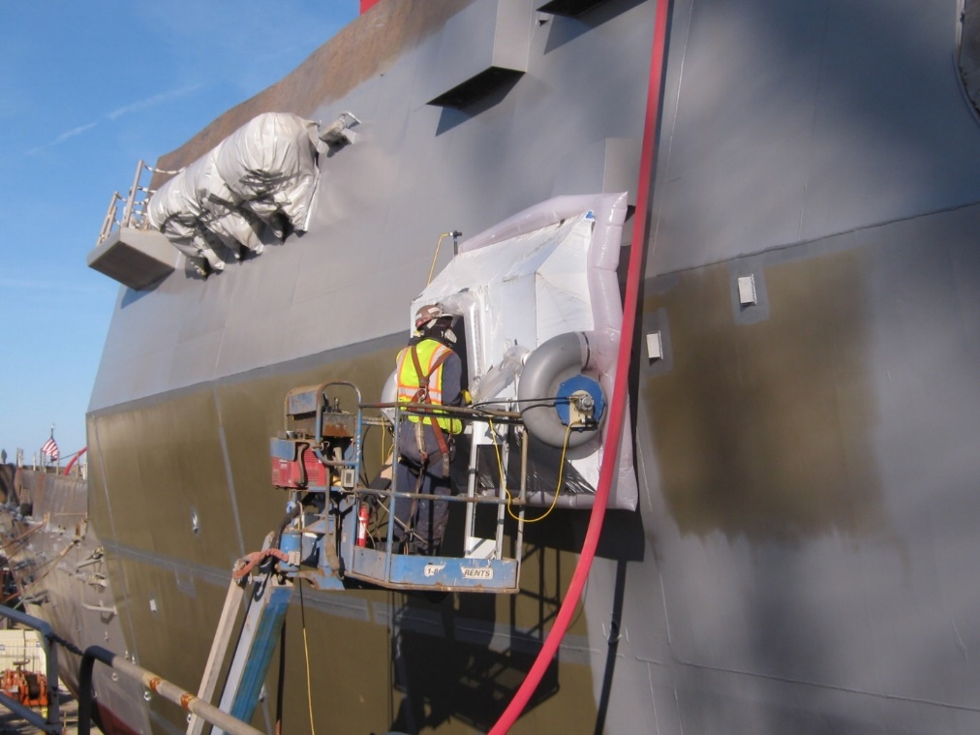

Not Export Controlled per PS-2018-DR-469

Figure BCEE along a DDG at BAE Systems JSR

### Trial Two

The second use was on a 300-foot support craft Ranger*.* The ship was positioned on the yard’s marine railway and had unencumbered boomlift access from both sides. The ship’s starboard side approximately 3000 square feet was painted with open air spraying. The ship’s port side approximately 3000 square feet was painted using the BCEE. The starboard side was painted in 40 minutes with significant visual overspray. The port side was painted in 60 minutes with no visible overspray.

Not Export Controlled per PS-2018-DR-469

Not Export Controlled per PS-2018-DR-469

All aspects were the same for this trial – boomlift access and positioning and skill level of the two painters. The BCEE set up was not included in the trial but only takes 5 minutes to install in the boomlift. Open spray was 33% faster than the BCEE. If overspray capture at 95% efficiency was required to get this ship painted in this location the ship would have had to have been tarped or shrink wrapped. Typically, staging is also required, which in turn limits access of the boomlifts. You can see from the picture below (Figure 14) a fully staged and shrink wrapped enclosure just to the right of Ranger. These kinds of costs vary from ship to ship location in the yard and from shipyard to shipyard. They are expensive to build and maintain. Where overspray capture is your only concern for the project the BCEE can be deployed with a 30% increase in your spray times per coat.

Figure 13 Painting of the Ranger Not Export Controlled per PS-2018-DR-469

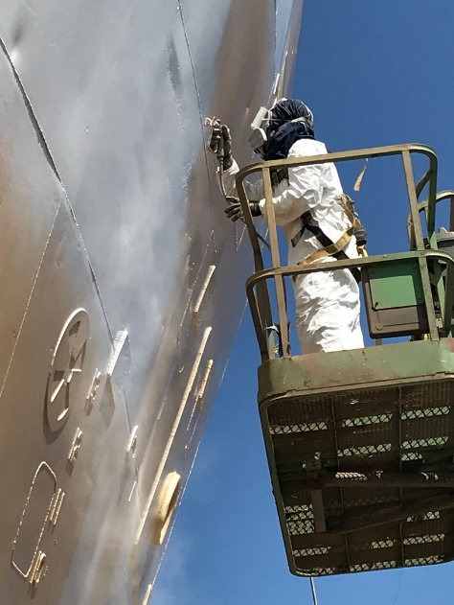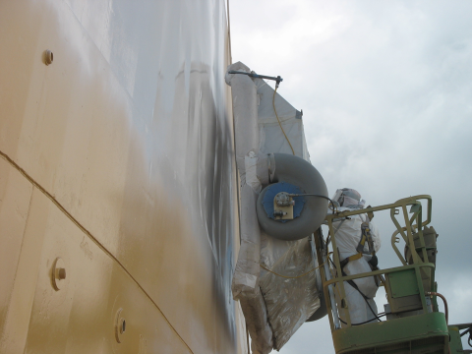

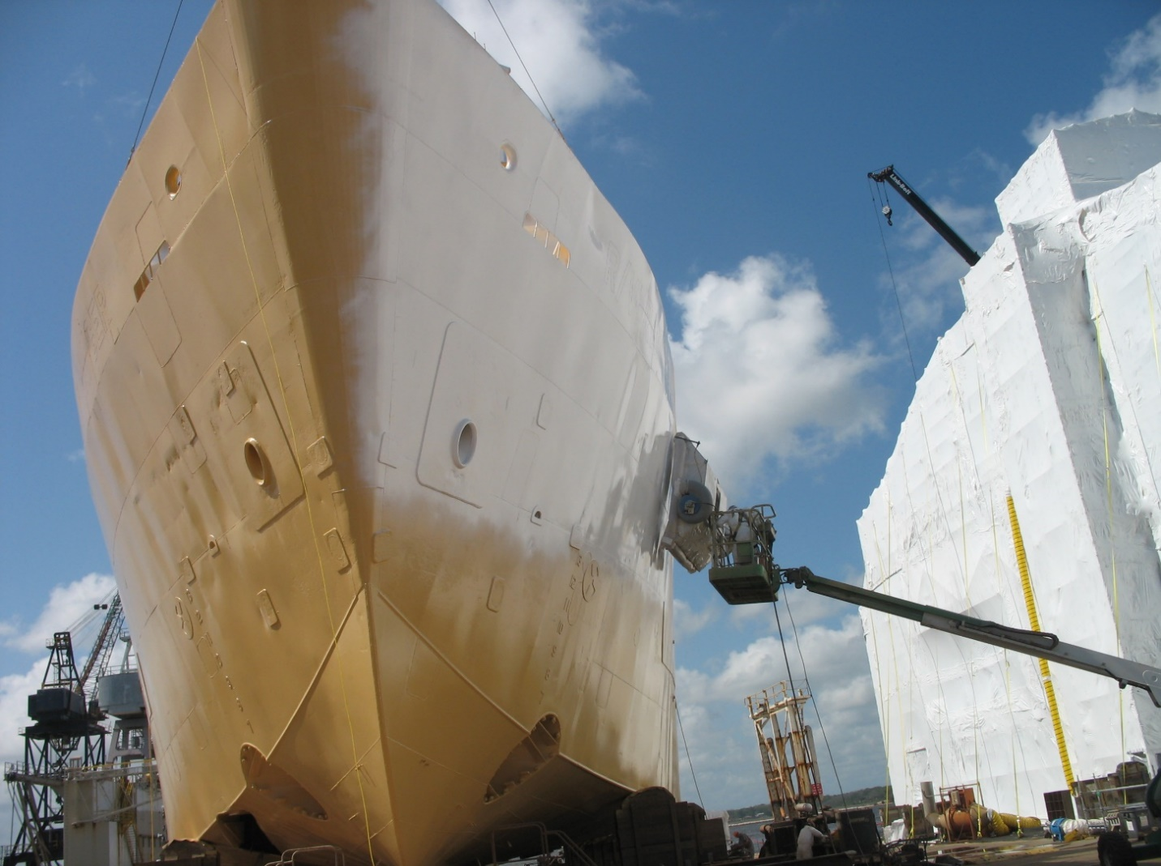

Figure Painting of the Ranger Not Export Controlled per PS-2018-DR-469

### Trial Three

The third trial was on a 320 foot Mega Yacht. The ship was positioned on the yard’s marine railway and had unencumbered boomlift access from both sides. These underwater hulls are typically power rolled to keep from getting overspray on the ship’s topside super high gloss Mega Yacht finish. The water line is taped and a fly sheet is installed on the freeboard for power roll or airless spray. Full containment costs are prohibitive and can increase the cost of the underwater hull by 300%. Power rolling is effective but requires two roll coats for each coat of paint in order to achieve the proper film thickness as compared to airless spray. This is accomplished at 150% more man-hours and 50% additional days to schedule as compared to BCEE airless spray.

The unit can be placed in the boomlift and operational in less than 5 minutes. A single operator controls the lift, position of the BCEE and the airless spray. The BCEE tilts to the angle of the ship and can be use down to the bilge keel level (approximately 12 feet). The bilge keel to the keel is sprayed with a low-pressure controlled airless spray.

The BCEE is being used in the yard regularly to capture overspray on Mega Yacht projects.

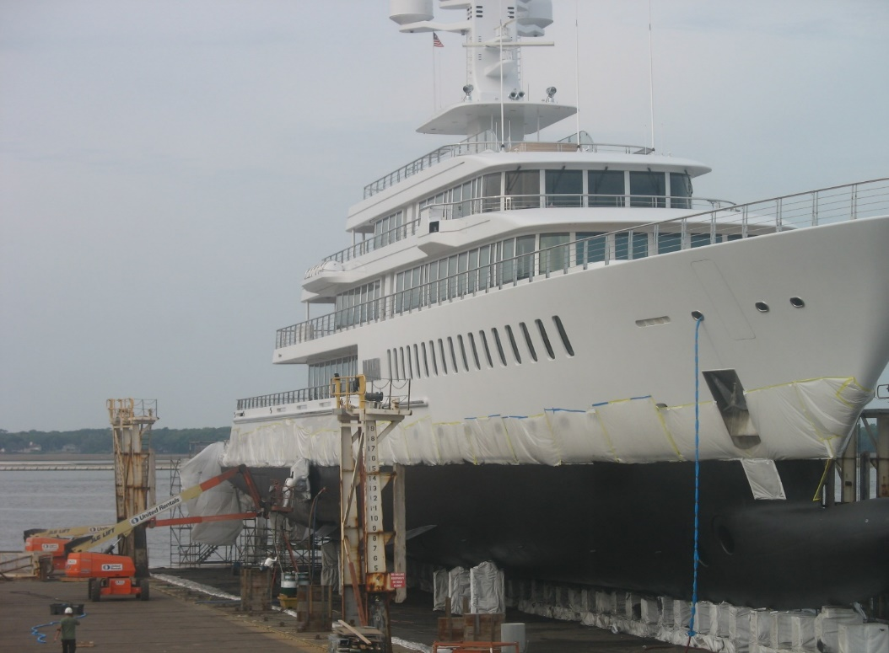

Figure BCEE Painting a MegaYacht Not Export Controlled per PS-2018-DR-469

## General Dynamics – National Steel and Shipbuilding Company

In May 2018, the 2nd BCEE unit was shipped to GD-NASSCO in San Diego, CA.

### 

Figure 16 Loading BCEE into Basket at GD-NASSCO

The unit was loaded into a Genie S-65 (Figure 16) and used to paint a section of the freeboard of the USNS Miguel Keith (T-ESB-5). The Miguel Keith is currently under construction in a graving dock. Since the target area was above the wall of the graving dock, the Genie S-65 was positioned pier side. The observed wind speed on the pier was 7 mph. Due to obstructions; the wind speed at the application site would have been less.

The Genie S-65 is a jib-style boomlift with a maximum capacity of 500 lbs. Therefore, a single operator both maneuvered the unit and painted the surface. The positioning was inconsistent (i.e., standoff was varied) but there was no observable overspray. On an early approach, the operator attempted to correct the enclosure alignment with the boomlift’s rotate joint while close to the surface. As a result, the enclosure rubbed against the surface. The operator was reminded to only make Rotate and Swing corrections when away from the surface and no further rubbing was observed.

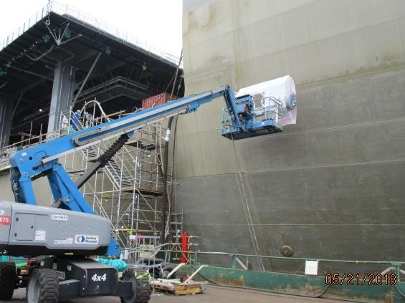

Figure 17 BCEE on Genie S-65 Approaching USNS Miguel Keith

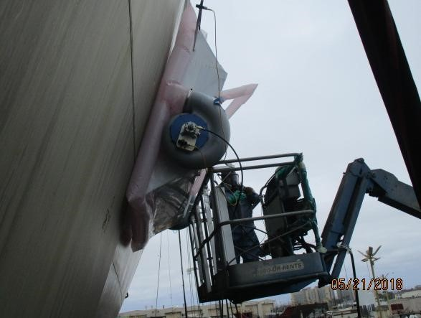 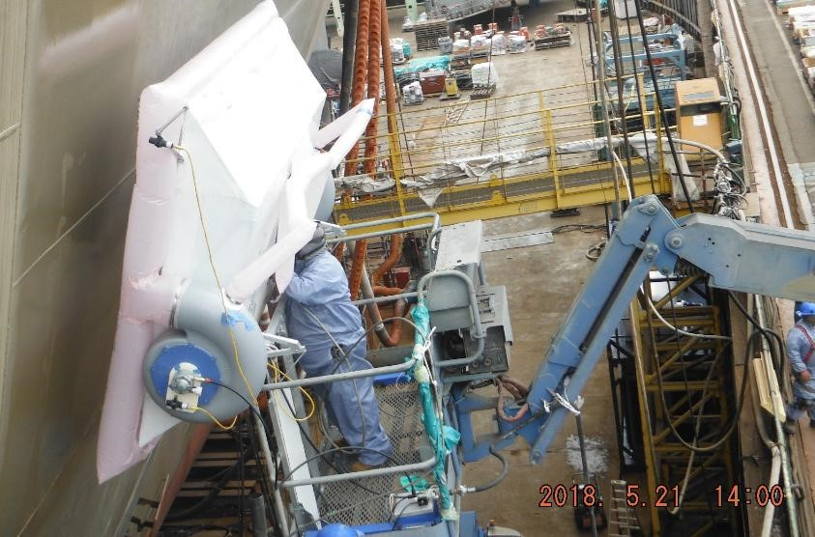

Figure 8 BCEE in a Genie S-65 alongside USNS Miquel Keith

## General Dynamics – Bath Iron Works

In June 2018, the 2nd BCEE unit was shipped to GD-BIW in Bath, ME.

The BCEE was transported by rail to GD-BIW. The rail transit caused minor damage. The BCEE sustained a broken shear pin on a rear enclosure brace and small tears to the enclosure skin and forward pillow skirt. The shear pin is a #6 nylon bolt meant to shear before stresses can damage other components of the enclosure. After repairs, the unit was assembled and tested. The battery voltage had fallen beneath 12 volts, and was recharged.

The unit was loaded into a Genie S-80X then used to paint a section of the freeboard of the USS Lyndon B. Johnson (DDG-1002). The Lyndon B. Johnson is currently under construction on the Land Level Transfer Facility (LLTF) and the Genie was positioned alongside on the LLTF inside of the crane rails. The wind speed was 3 mph.

The USS Lyndon B. Johnson, a Zumwalt class DDG, has a distinctive tumblehome hull. Therefore, the forward tilt option for the BCEE was used (Figure 19). The forward tilt option adds bars to the enclosure mount points and generate a 15° forward tilt.

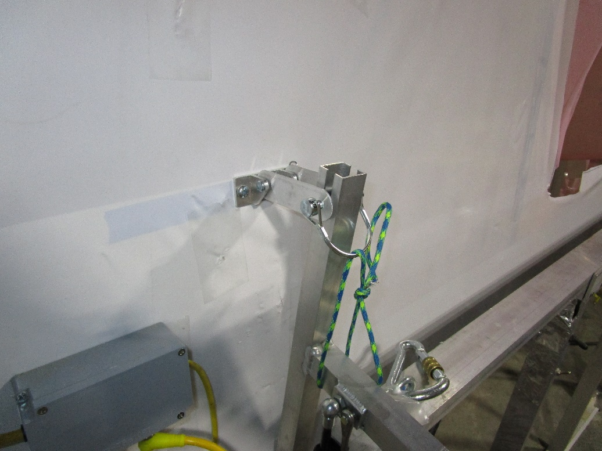

Figure 19 BCEE Forward Tilt Adapter

The Genie S-80X is a stick-style boomlift with a maximum capacity of 1000 lbs. With 800 pounds available for personnel, two operators maneuvered the unit and painted the surface. The positioning operator was very skillful and consistently positioned the BCEE along the surface without using the sensor cues.

There was no observable overspray through most of the trial. However, overspray was seen to escape in one instance when the painter applied paint near the lower seal plenum. The painter had been cautioned that a directed paint spray would overwhelm the seal, but decided to try. There was no subsequently observed overspray.

The GD-BIW ship trial provided the opportunity to observe BCEE use in proximity to other on-going work. During the ship trial, other yard personnel conducted a high-pressure water wash down forward of the paint application area. In addition, electrical work was being performed immediately beneath the paint trial area. While we do not know the specifics of the work, the casual indifference to the painting demonstrates an advantage of painting within an enclosure.

Photographs of the ship trial were taken, but were not released in time for publication prior to the submission of this report.

## Mid-Program Modifications

Twelve modifications were applied to the BCEE#1 in building BCEE#2. Two of these modifications (Welded Frame and reduced Enclosure Angle) were derived from the initial fit-and-function test. The other nine modifications were derived from experiences at BAE Systems JSR.

### Welded Frame

BCEE#1 was built for a series of “fit and function” tests using “glue and screw” techniques that are generally not suitable for use in a shipyard. The second prototype has a welded base frame.

### Enclosure Angle

The angle at the top and bottom of the controller was changed from 45° to 37°. The change improves the operator access through the forward basket gate common on Genie boomlifts. The preferred method to enter the basket remains to tilt the basket back several degrees before entering.

### Forward Tilt

To accommodate Tumblehome or forward leaning ship surfaces, the BCEE enclosure mount was modified to permit the insertion of a bar that could impart a 10° or 15° forward tilt. The forward tilt was used during the ship trial at GD-Bath Iron Works.

### Interface Pendant

The original operator interface of flashing lights was replaced with a pendant with an 8 x 8 LED matrix display. The matrix can display a two-digit number (one 4 pixel wide digit and one 3 pixel wide digit), icons and status indicators. The new interface supports field calibration, surface approach, and surface following.

Field calibration consists of adjusting the sensor positions to properly reflect the distance between the surface and the seal plenum. The matrix displays the distance in inches. The 4-pixel digit on the left shows the unit inches and the 3-pixel digit on the right shows eighths of an inch. Indicators in the top row of the matrix show the sensor currently displayed (port, starboard, or high). To calibrate, the operator positions the BCEE 4” to 6” from the surface, measures the distance from the surface to the inflated seal plenum, then slides the sensor in its holder until the displayed distance matches the measured distance.

To keep the BCEE from touching the surface due to boom sway, the BCEE must be positioned off the surface and the final approach made with only the lift or extend joints. The approach position could be more than the 9 7/8” displayable with the field calibration mode. Therefore when the standoff exceeds 10 inches, the display shows the tens digit as a 3-pixel digit on the left and the unit digit as a 4-pixel digit on the right. The yaw and pitch alignments are shown by flashing LEDs in the top row of the matrix.

Productivity may be enhanced by moving the BCEE along the surface rather than withdrawing from the surface between paint areas. The display supports surface motion with icons which instruct the operator to extend or retract the boom rather than displaying the actually distance. This technique also allows the operator to change the target standoff. While the standoff is nominally 4 inches, the operator may desire to use a 3-inch nominal standoff while moving up or a 5-inch nominal standoff while moving down to compensate for the basket’s tendency to draw away from or towards the surface during vertical motions.

### Power Relay

BCEE#1 uses a dual connection to the battery. Both contacts have to be made for the system to be powered. The basis of this approach was that the operator would remember to disconnect at least one of the battery connections. However, in the yard, the operator consistently failed to disconnect either connection. Left in this state, with the display and sensors on, the battery would bleed out following several idle days. To correct this situation, the controller was changed to support an auto-off function.

First, the battery box was enlarged. The larger battery box contains the battery, the controller, and the sensor isolation electronics. (The display may also be stored within the battery box between uses.) This approach supports the other changes and eliminates several loose wires that could be problematic in a yard.

Power relays were added to the controller. The controller engages the relays at startup and holds them closed while operating. The relays allow the controller to disconnect the power when the system has been idle for a prolonged time, currently 30 minutes. To the controller, any button push or switch throw on the interface pendant indicates the system is in use.

Finally, the single e-stop button was augmented with a momentary start button. The new controller is initiated by first pulling the e-stop button then pressing, and holding, a green start button. If the controller disconnects during use, the operator re-engages the start button.

### Button Box

Shipyard personnel expressed general concerns about electronics. A controller failure could leave the BCEE inoperable at an inconvenient time. A button box is provided with BCEE#2 to give an immediate, although less capable, fix. The button box is a momentary rocker switch that directs the battery power to the motors. The operator tilts the enclosure as he deems appropriate based on his direct observation of the surface-enclosure standoff. The sensors do not function when using the Button Box.

A single connector within the battery box connects both the battery and the motors to the controller. The button box lead replaces the controller at that connector. Afterwards only the red e-stop button need be pulled to power the system and the operator takes the place of the controller. Since there are no active electronics, the battery will also not drain if the painter fails to re-engage the e-stop.

### Storage Crate

The competing requirements of large size and small weight requires the BCEE be constructed of thin materials where incidental impacts could cause damage. Loose storage on a deck or along a wall, increases the possibility of damage between jobs. Therefore, the shipping crate and the BCEE enclosure have been modified to provide between job storage. The enclosure’s high sensor has been moved from above the upper plenum to outside of the side plenum. The crate frame has been reinforced and hooks have been added to the rear wall. The hooks are spaced the same as the tilt arms on the BCEE frame. Once the front and two sides of the crate have been removed, the assembled enclosure may be carried into the crate and hung on the rear wall. The BCEE frame can then be placed on the crate’s deck along with the service box. Lock pins are provided at the rear wall hooks to hold the enclosure in place while being moved by forklift or pallet jack.

### Operator Training

##### The operator must be trained on the BCEE’s specifics, safety restrictions, and the specific maneuvering requirements of the boomlift. As with any new tool, the operator requires training on the operation, the operator inputs to, and the feedback provided by the BCEE. Safety restrictions impose operation limits such as maximum wind speed (10 mph), maximum use height (80 feet), and reduction of boomlift capacity (190 lbs plus 40 lbs for the hose). The operator must understand the enhanced level of concern of typical boomlift safety concerns such as avoiding electrical wires and hot work as the BCEE is electrically conductive and polyethylene will burn in the presence of flame. Basic operator boomlift training generally does not include the techniques needed to maneuver as close to a surface as the BCEE operates.

##### The BCEE must maintain an approximately 6” standoff from the surface to have an effective seal. Operators are generally not trained how to safely maneuver a boomlift that close to a surface. Operators must be taught to approach a surface with only the boomlift’s Extend and Lift joints. A boomlift’s extension boom is a set of concentric metal tubes riding on polymer slides. The application of a swing torque at one end and an inertial load (the basket) at the other causes the boom to sway side to side. When close to a surface, only an incredibly skilled operator could keep the swaying BCEE from touching the surface. However, when a lift torque is applied to the boom, the weight of the inertial load preloads the tubes and there is no swaying. Similarly, the extend force is applied to the boom’s metal tubes through tensioned wire ropes and also does not generate a sway. Therefore, the operator must be trained to make the final approach to the surface only with the boomlift’s lift and extend joints.

### Supervisor Training

The safety and operating limitations must be appreciated by the supervisor for effective use of the BCEE. The safety restrictions are the same as for the operator listed above (wind, height, conductivity, flammability, etc.). The operating limitations requires the supervisor provide a clear dry-dock deck area for the boomlift. To form a seal, the BCEE must be close to and parallel to the surface being painted. The final approach must be along the Lift/Extend plain of the boomlift. This necessitates the boomlift’s base to be several feet from the surface for there to be a suitable angle between the surface and the boomlift’s boom.

The basket rotation of a Genie telescoping boom lift is ±80° from center [genie ref]. Therefore, there is minimum 10° angle between the paint surface and boom. 10° is an extreme angle and a greater angle should be used when possible. The boomlift’s base standoff is the horizontal boom length (H) times the sine of the angle (α), plus depth of the basket (B), plus the depth of the BCEE enclosure (E), plus the plenum and enclosure standoff (P), minus half of the boomlift base width (W), (*S = H sin(α) + B + E + P – W*), where B=4’, E=2’, P=1’, and W=4’ to 5’. Thus, the standoff with a 60-foot boom would be about 12’ and the supervisor must ensure a 10’ wide area at least 12’ from the paint surface is available to position the boomlift.

### Practice Tool

The utility of the BCEE depends on the skill level of the operator. The unique skill required by the BCEE is boomlift maneuvering. We therefore developed a tool the operator can use to practice approaches without installing the BCEE. The Practice Tool includes a single sensor, a controller, and four lantern batteries for power. The Practice Tool uses the same Interface Pendant as the BCEE controller. However, with only a single sensor, the Practice Tool does not display yaw or pitch errors.

The practice tool rests on the basket deck behind the forward kick skirt. The tool leaves an unencumbered view of the surface and allows the operator to appreciate the effects of his actions without risking surface contact. The operator should practice multiple approaches at various surface-boom angles before using the BCEE.

### Plenum Skirt

A minor modification from the BAE Systems JSR experience is a plenum skirt. When inflated, the plenum pushes against the forward frame of the enclosure. However, when not inflated the plenum hangs loosely from the enclosure. To reduce the chance of snagging the uninflated plenum, a 4” wide skirt was added to the top and bottom sections of the plenum. The skirt is then taped to the enclosure skin, which limits the amount of sag.

### Lift Signal Attenuation

Several Genie boomlifts present an opportunity to improve productivity through simultaneous painting and motion. The Genie S-60X and S-80X boomlift’s have a 1000 lbs restricted reach capacity. Thus, two operators can share the basket with the BCEE. One operator can paint while the second operator moves the BCEE along the surface. Significant practice is required to use this enhancement.

As explained before, possible boom sway limits the surface motions to the lift/extend plane (i.e., primarily vertical). Simultaneous motion also requires a very slow speed (1 ips to 2 ips). To assist the operator in maintaining the necessary speed, an attenuator is added to the lift actuator input signal (Genie has certified the use of the attenuator). The attenuator device consists of a switch and a knob. The switch engages (or disengages) the attenuator while the knob controls the amount of attenuation. When the knob is fully counter-clockwise, the lift actuator signal is fully attenuated and the lift axis will not move even when the joystick is in the maximum position. As the knob is rotated clockwise, more of the lift actuator signal is sent to the boomlift’s controller.

To use the attenuator, the second operator approaches the surface, as would a lone operator. Once in position, and the painting operator is ready, the second operator engages the attenuator in the full attenuated position, then engages the boomlift’s footswitch, puts the lift actuator joystick in the full position, and rotates the knob until the BCEE begins to move. The painting operator applies paint and directs the second operator to move faster or slower. The second operator adjusts the knob until the surface speed matches the painting operator’s instruction. The second operator watches the interface pendant and uses the extend actuator to maintain the appropriate standoff.

Simultaneous paint and motion requires skills not commonly taught to shipyard boomlift operators. The project time in the shipyards was not sufficient to implement simultaneous motion. The capability remains with the units for use by the shipyards when appropriate.

# Results

Similar observations were made at each trial by Supervisors, Painters and observers. Painter initial comments were along the lines of awkward and slow. As they got some experience in the BCEE it got faster and more maneuverable but still slow. Supervisor’s initial comments were “I see the benefits and potential uses but it is slow, will it really save me?” All observers including Supervisors and Painters and anyone who stopped by to watch the spray operation are “Wow that thing really catches the overspray”. From the experience at BAE Systems JSR with E tanks, MAEE and BCEE production rates improve with experience. The weight and capture rate of the BCEE make it shipyard ready. It can go from storage to boomlift in less than 10 minutes. Set up at the ship is a ¾” airline. Time studies included below show it is 33% slower than airless spray and at least twice as fast as roller application.

Scaffolding, Tarp Systems, Shrink-wrap costs vary from ship to ship, location in the yard and from shipyard to shipyard. They are expensive to build and maintain. Where overspray capture is your only concern for the project the BCEE can be deployed with a 30% increase in your spray times per coat

The estimated expected production rate was computed from the timed comparison on the *Ranger* and previously established production rates for shipyard painters. Based on the Ranger data, the painter production rate with the BCEE is 67% of the production rate with an airless sprayer (40 min/60 min). In general, a painter can coat 8,000 ft2/shift to 12,000 ft2/shift with an airless spray gun [NSRP]. Thus, the expected production rate with the BCEE is 5,000 ft2/shift to 8,000 ft2/shift. The alternative portable overspray-free production technique is roller or power roller application. A painter generally rolls between 2,000 ft2/shift and 4,000 ft2/shift [NSRP]. Thus, the expected production rate with the BCEE is 2-2 ½ times the production rate of the alternative overspray-free method.

.The mid-project modifications provided mixed benefits. The cosmetic improvements (reducing the hanging plenums) were useful. The numeric standoff displays added little to no value (the final test operator suggested window mounted lights). The converted crate to storage rack was very beneficial. The enhanced performance measures (hull following) were generally beyond the operator’s skills without more experience. The forward tilt capability proved to be vital for some ships. While the safety training was an unquestionable benefit, other instructions did not deter the operators from exceeding the BCEE’s limits (at least until they could experience the effect). The auto-off feature (power relays) was a positive benefit with the appropriateness of the duration to be determined.

The GD-BIW ship trial provided the opportunity to observe BCEE use in proximity to other on-going work. During the ship trial, other yard personnel conducted a high-pressure water wash down forward of the paint application area. In addition, electrical work was being performed immediately beneath the paint trial area. While we do not know the specifics of the work, the casual indifference to the painting demonstrates an advantage of painting within an enclosure.

Cost evaluation of the BCEE vs containment costs are site specific. It will require a yard to compare their containment cost by size and location in their yard against a 30% increase in airless spray time (or 50% reduction in roller application time) and the cost of the BCEE to develop a site specific ROI.

The most telling conclusion of the BCEE trials was best summarized by the environmental office observer from GD-BIW who said, “It does what it’s supposed to do.”

# Project Participants

Rick Norcross Norx LLC ([norxllc@comcast.net](mailto:norxllc@comcast.net))

Bill Thomas Norx LLC

Stephen Cogswell BAE Systems. Jacksonville Ship Repair

Paint Dept. BAE Systems JSR

Angel Zepeda GD NASSCO San Diego

Paint Dept. GD NASSCO San Diego

Robert Cloutier GD BIW

Paint Dept. GD BIW

Many thanks for the support and patience in completing this project.

NSRP Environmental Panel

NSRP Surface Preparation and Coating Panel

# References

[ANSI] ANSI, 2006, *American National Standard for Boom Supported Elevated Work Platforms* (ANSI SIA A92.5 2005), ANSI, New York, NY, 2006.

[Glauert] Glauert MB, “The Wall Jet.” *J. Fluid Mechanics*, Vol. 1, Part 5, 1956, pp. 625-643.

[Hertel] Hertel W, Norcross R, (2018) US Patent *9,975,135*, NSWC-CD, West Bethesda, MD.

[Kane] Kane M, Jorgensen C, and Sybil D, (1997) US Patent *5,688,323,* Seattle, WA. Interstate Coatings Incorporated.

[NAVSEA] NAVSEA Standard Item 0009-32, “Cleaning and Painting Requirements”, Nov 2013, [www.navsea.navy.mil/Portals/103/Documents/SSRAC/NSI/FY15/009-32_FY15.pdf](http://www.navsea.navy.mil/Portals/103/Documents/SSRAC/NSI/FY15/009-32_FY15.pdf)

[Norcross] Norcross R, (2013) US Patent *8,499,716*, Darnestown, MD.

[Settles] Settles G., “[Visualization and collection of overspray from airless spray painting](https://www.researchgate.net/publication/252422752_Visualization_and_collection_of_overspray_from_airless_spray_painting?enrichId=rgreq-66fc9ccb580a240554eb28b1f161f3a8-XXX&enrichSource=Y292ZXJQYWdlOzI1MjQyMjc1MjtBUzoyMzIzMTg5MjUyNzUxMzZAMTQzMjQwMDU1NjE0NQ%3D%3D&el=1_x_3&_esc=publicationCoverPdf)” *8th International Symposium on Flow Visualization, At Sorrento, Italy*, 1998. https://www.researchgate.net/publication/252422752_Visualization_and_collection_of_overspray_from_airless_spray_painting

[NORC] Norcross R, “Perforated Tube Overspray Containment Seal Evaluation”**,** Office of Naval Research (Code 332) Contract N00014-12-M-0347, 2012.

[NSRP] NSRP-SPC-SP023/1 (1979) “Paint and Surface Preparation Training Program for Shipyard Personnel”, [www.dtic.mil/dtic/tr/fullext/u2/a443925.pdf](http://www.dtic.mil/dtic/tr/fullext/u2/a443925.pdf), p C.16.

[OPNAV] OPNAV N45 Public Affairs, “APACTS Has Impact On Paint Emissions”, www.navy.mil/submit/display.asp?story_id=2908, NNS020729-22, July 2002.