Panel Project Guide
Volume 2 – Panel Chairs

Revision T
June 3, 2020

MISSION
- The mission of the National Shipbuilding Research Program (NSRP) is to reduce the total ownership cost and improve the capabilities of both United States Government and U. S.-flag commercial ships.

- The Program accomplishes this mission by providing a collaborative framework to manage, focus, develop, and share research and development and leverage best practices in shipbuilding and ship repair.

Table of Contents
BACKGROUND 2
Panel Structure 2
Panel Meetings 2
Panel Projects 3
PANEL PROJECTS SOLICITATION AND SELECTION 3
White Paper Requirements 4
Joint Panel Submission Process 5
Cost Data Table 5
Submission Process 6
Review 6
Selection And Award 6
POST-AWARD GUIDELINES 6
Contracting 6
Project Oversight 7
ATTACHMENTS 8
ATTACHMENT 1 – White Paper Template 9
ATTACHMENT 2 – Supporting Cost Data Table 11
ATTACHMENT 3 – Cost Data Table Example 15
ATTACHMENT 4 – White Paper Checklist 16
ATTACHMENT 5 – White Paper Submission Module and Instructions 17

BACKGROUND
This guide has been created to assist Panel Chairs with the white paper submission, voting, and selection process, and to provide guidance once project funding has been awarded.

PANEL STRUCTURE
The nine-panel structure corresponds to narrow technical and/or process areas, while being aligned to the four broader major initiatives of the multi-year NSRP Strategic Investment Plan (SIP) and as amplified by this year’s annual Technology Investment Plan (TIP). The panels form the working groups of the program and are considered the program’s front line communication source for engaging with industry, Navy, other Government organizations, and the commercial sector. Each panel elects a chair and vice-chair who lead and coordinate the panel activities, which include open industry meetings and execution of smaller-scale projects.
The NSRP website includes individual panel webpages, which publish meeting information and other pertinent data.
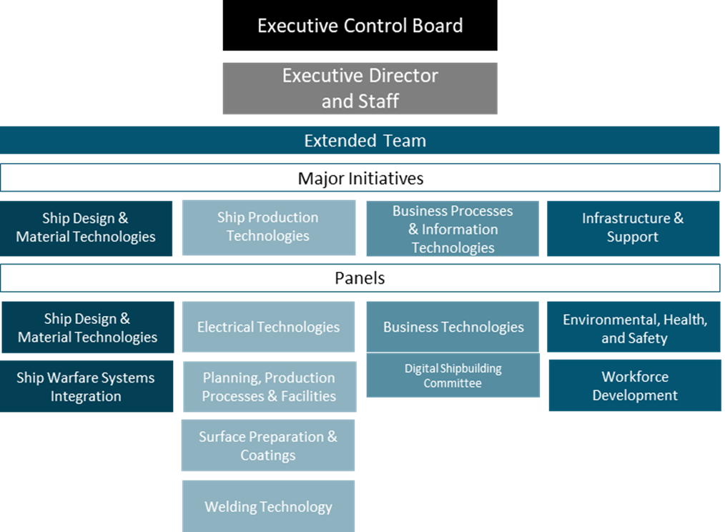
Figure 1 - Panel Alignment with Major Initiatives

PANEL MEETINGS
As with the Major Initiative Team Leaders, the Panel Chairs provide input and recommendations on key elements of the Program. However, the core focus of the Panels is open interaction with the industry at large, as well as with Government representatives, the commercial sector, and members of academia engaged in their respective functional areas.
This interaction is accomplished primarily through two to four open meetings per panel per year. These meetings serve a critical role within the Program by providing a public forum for industry-wide networking, technology transfer and discussion of current Government and industry topics of interest.

PANEL PROJECTS
Panel meeting discussions regularly reveal project opportunities that are important to the shipbuilding and ship repair industry, but are smaller in scope, lower in cost, and of a shorter duration than NSRP Research Announcement (RA) projects. The Executive Control Board (ECB) typically sets aside a specific amount of money each year to fund these relatively small, short-term projects recommended by the Panel Chairs.
Current and historical projects for both panel and RA projects can be found in the NSRP Project Portfolio.

PANEL PROJECTS SOLICITATION AND SELECTION
The solicitation for each cycle will be announced via email to the Panel Chairs and published on the NSRP program website. The solicitation will include a due date for offerors to submit their white papers to the appropriate Panel Chair and the Program Administrator, Advanced Technology International (ATI) (nsrp@ati.org), as well as the due date for Panel Chairs to submit the top three white papers selected by the panel, to ATI. No formal Request for Proposals will be issued. The proposed program funding amount must not exceed $150,000 for any one project, and a proposed project must not exceed 12 months in duration. At the ECB’s discretion, any ongoing NSRP Working Group or other ad hoc team may also compete in the Panel Project solicitation process.
Below is a flow chart illustrating the panel project white paper submission and selection process:
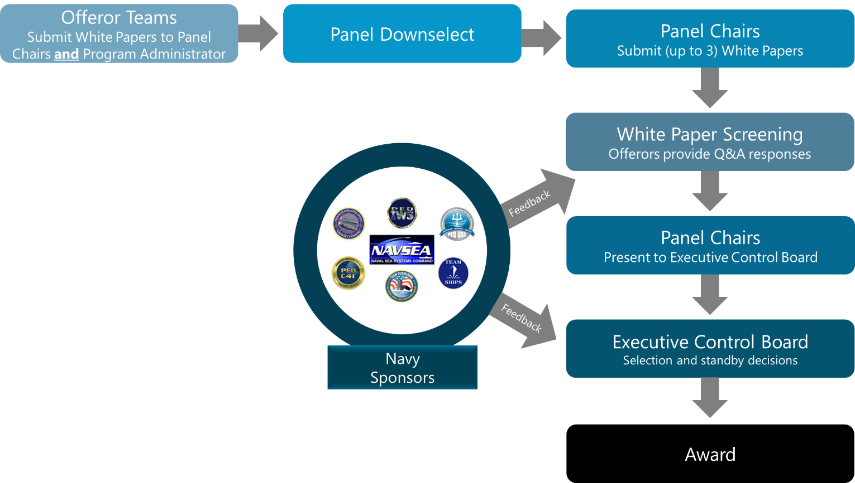

Figure 2 - Panel Project Selection Process

WHITE PAPER REQUIREMENTS
White paper requirements for this solicitation include the following:
- First Page with Project Lead point(s) of contact information and any required signatures
- No more than three pages
- No more than $150,000 in program-funded costs
- No more than 12 months in duration
- At least one member shipyard should be a project participant – multiple shipyard participation is strongly encouraged. An endorsement email for each participating member shipyard (specifically, an email from that yard’s NSRP Shipyard Delegate (NSD)) must be attached. These endorsement pages do not count toward the three page limit.
- If a Government organization will participate in the project, provide the name and contact information for the government point of contact who agreed to participate.
White papers must contain all required information, which will enable ECB decision-making that meets their accountability to funding sponsors and responsibility for sound resource allocation. Panel Chairs will screen the proposals received and may, at their discretion, remove non-compliant technical proposals from consideration by the panel. Submissions must include the following:
- Brief description of the following, limited to three pages in length. The white paper should fully describe the topics itemized below at a level of detail appropriate for executive-level decision making. Extensive technical details are not required (Attachment 1 – White Paper Template):
  - Identification of Project Technical Lead (full name, title, email address, phone number)
  - Identification of Project Prime Contractor (full name, title, email address, phone number)
  - Identification of point of contact for each participating ECB member shipyard (full name, title, email address, phone number)
  - Identification of participating Government agencies (agency, full name, title, email address, phone number)
  - Problem Statement/Concept Description
  - Goals and Objectives
  - Methods and Procedures Required for Accomplishing Goals and Objectives
  - Previous and Current Related Work (e.g., previous NSRP projects, follow-on projects, other R&D (i.e., ManTech, SBIR/STTR projects))
  - Deliverables
  - Project Benefits
  - Customer Involvement
  - Foreign involvement (explain how compliance with ITAR and other applicable regulations will be achieved, and describe the likely impact on schedule)
  - All projects, if applicable, shall include Government Purpose Rights. Unless otherwise specifically negotiated and approved, the Government will obtain Government Purpose Rights to all intellectual property (IP) developed under the NSRP Program including IP developed using cost share sources. Any request for specially-negotiated rights other than Government Purpose Rights must be disclosed in the white paper for consideration and approval. Specially-negotiated rights are subject to approval by the NAVSEA NSRP Agreements Officer prior to award.
  - Technology Transfer and Implementation Approach
  - Expected Duration (not to exceed 12 months)
  - Program Funds (Note: Fee or profit is not allowed)
  - Cost Share (if applicable)
  - The first page must include point of contact information for each member shipyard acting as a project participant to include: first and last name, email address, and phone number.
  - Offeror must include an email endorsement from the NSRP Shipyard Delegate for each member shipyard acting as a project participant. (NOTE: This does not include member shipyards who are simply monitoring the project or acting as an observer.)
- Fee or profit associated with the work is not allowed for panel project awards to NSRP ECB member shipyards, or other recipients who are performing research deemed substantive to the goals of NSRP program. On a case-by-case basis, fee/profit on panel project awards to small businesses (using SBA size standards) and commercial organizations that do not typically do government business may be authorized. Payment of reasonable fee or profit, when making purchases from suppliers of goods (e.g., supplies and equipment) or services needed to carry out the research, is allowable. The NSRP Agreements Officer must approve any fee/profit on proposed panel projects in advance of award.

JOINT PANEL SUBMISSION PROCESS
White papers for Joint Panel Projects involving two or more panels may be submitted in addition to each panel’s individual submissions. No one panel may be part of more than one joint panel project white paper. Offerors must identify a single, lead panel and submit their joint panel white paper directly to that Panel Chair. The Panel Chair of the lead panel will be responsible for presenting the proposal to the ECB. If awarded, the lead Panel Chair will be responsible for proposing a Program Technical Representative (PTR) for Program Administrator approval.

COST DATA TABLE
Offerors will not provide the “Supporting Cost Data Table” to the Panel Chairs with their white paper submission. Offerors should have this Cost Table developed by the deadline for submission of white papers to the Panel Chairs, indicating that proposal development is complete in all respects. Offerors must submit Cost Data Table directly to ATI (nsrp@ati.org) within three (3) business days of notification by the Panel Chair their white paper was one of the ones downselected for submission to the ECB, but no later than 12:00 p.m. (noon) ET on September 9, 2020.

Offerors are strongly encouraged to consider all elements of cost and obtain concurrence from their contracting staffs well in advance of the white paper down-select decisions. This cost table (shown at Attachment 2 and as an example in Attachment 3) will be an official proposal and there will not be a formal request for proposal (RFP) associated with this solicitation.

SUBMISSION PROCESS
Offerors shall submit white papers directly to the appropriate Panel Chair and ATI (nsrp@ati.org), using the template outlined in Attachment 1 and after complying with the checklist provided in Attachment 4. Panel Chairs and their panel members then conduct an internal review and prioritization of the white papers submitted. The final step in the submission process is for Panel Chairs to submit up to three rank-ordered white papers and up to one joint panel project white paper, with NSRP member shipyard voting and NSRP Shipyard Delegate endorsement(s) directly to the ATI NSRP Staff via the White Paper Submission Module as outlined in Attachment 5.

REVIEW
In addition to the panel review, the ATI NSRP Staff will conduct a review to identify any non-compliance issues, which might eliminate consideration by the ECB. Navy and other Government funding sponsors will also be given the opportunity to review the white papers The ATI NSRP Staff will notify the offerors of any potential issues with their White Papers, with a copy to the appropriate Panel Chair. The offerors will submit responses to any issues raised to the ATI NSRP Staff, with copies to the appropriate Panel Chair, by October 2, 2020.
Clarifications from the offeror to the Panel Chair will help the Panel Chair prepare for their oral presentations to the ECB during the Panel Project Selection Meeting.

SELECTION AND AWARD
Panel Chairs or their appointed representative will present all compliant and selected white papers to the ECB. The ECB will select panel projects for award based on strategic fit and value to the shipbuilding and ship repair industry, Navy, other Government sponsors, and the commercial sector according to the evaluation criteria cited in the solicitation.
Please refer to the current Panel Project Solicitation for evaluation criteria.

POST-AWARD GUIDELINES

CONTRACTING
The ECB employs Advanced Technology International (ATI) as Program Administrator for NSRP operations, including contracting. Funds are distributed to NSRP project participants through Task Order awards managed by the Program Administrator.
A description of the payment methods available may be found in Article V of the Base Task Order Agreement. The preferred Payment Method is “Expenditure Based”. Use of the “Fixed-Support” Payment Method is limited only to organizations whose accounting systems do not have the capability to collect and invoice based on actual costs incurred. Organizations who request Fixed Support task orders will have to complete a Business System Information Questionnaire that is subject to review and approval by the Program Administrator.
Note: The payment method identified in the white paper may or may not be the type approved for award.
Offerors can contact Sarah H. Swain (sarah.swain@ati.org) for additional information related to the types of agreements available. The Base Task Order Agreement is available for review to ensure their organization can agree to the NSRP terms and conditions. These mandatory terms and conditions should be reviewed in detail prior to proposing. For additional contracting questions, please contact Sarah Swain.
Any proposed prime contractor shall ensure all subcontractors will agree to the terms and conditions of NSRP’s standard Base Task Order Agreement prior to submission of a white paper. To ensure selected projects can be awarded, all team members (both prime and subcontractors) shall:
- Ensure that contracting/legal departments agree with the terms and conditions of the agreement in advance. Resolve questions/issues ahead of time wherever possible.
- Ensure all team members’ (if applicable) contracting/legal departments are ready to contract once the project has been selected by the ECB. In most cases, this involves engaging with cost-estimating personnel to validate the cost summary .

PROJECT OVERSIGHT
Once proposals are selected for award, Panel Chairs are responsible for promptly identifying and providing contact information for the Technical Lead, Contract Lead and PTR for each project.
The Project Lead, as designated in the white paper, will be responsible for ensuring project objectives are being met, including:
- Once selected for award, submitting a draft Statement of Work (SOW) for approval.
- Completing deliverables and Project Status Reports according to the approved SOW
- Conducting Technology Transfer activities
- Submitting deliverables to the ATI NSRP Project Manager and Program Technical Representative (PTR) via the NSRP Deliverable Submission Module (DSM)
- Submitting invoices in a timely manner through ATI’s Accounting and Finance Group (AFG) via email (afgforms@ati.org).
The Panel Chair will propose a Program Technical Representative (PTR) for Program Administrator approval. Although normally the PTR role will fall to the Panel Officer population, conflict-of-interest concerns and Panel Officer workload may require the assignment of a panel member to this role.
To preclude against even the appearance of a conflict of interest, the PTR shall not be an employee of the company that is prime on the project. Additionally, as a general rule, the PTR should not be an employee of any company or organization receiving program funding on the project. Exceptions to this rule may be considered on a case-by-case basis, where the PTR is sufficiently insulated from their company’s project activity, but only after receiving concurrence from the ATI Head of Contracts and Procurement or his/her delegate.
The PTR will act in a role similar to the model of a Government Contracting Officer's Technical Representative. As a representative of the ECB, the PTR is responsible for overseeing a project's technical activities, adherence to schedule, and project resource usage in accordance with a contractually approved Statement of Work. PTRs do not hold the authority to change the project’s scope of work or making any other contractual decisions. The PTR will review and sign off on the SOW. The PTR will also review deliverables submitted via the NSRP DSM and approve acceptable submissions or identify where corrections or revisions are needed.

ATTACHMENTS
The attachments on the following pages can also be found on the Solicitation Resources page of the NSRP website. These attachments are provided to facilitate submission of a compliant panel project white paper and Supporting Cost Data Table.

ATTACHMENT 1 – White Paper Template
NOTE: Minimum font size is 11 pt

Title of Project: Provide a brief descriptive title that allows the reader to identify what is unique in that project.
Offeror Identification: Clearly identify by organization, Prime Contractor POC name, email address, and phone number. Include POC information for all other organizations who will participate including Government organizations (e.g., NRL, NSWC).
Problem Statement/Concept Description: What problem is being solved; what are the expected benefits? Avoid going into too much background detail. Identify industry members who have agreed to support this effort indirectly (e.g., list organizations that have agreed to participate in a survey or provide needed data)
- There is an industry need that is not being met
- There is an industry need to change an existing practice
- There is an industry need to develop new technology/ practice in ship construction and/or ship repair
Project Goals and Objectives: Why is the project being done? Provide goals and objectives that support why. Avoid going into detail about the benefits, covered in a subsequent section. Write to senior executives who may not be familiar with narrow technical details.
- Improve welding rate from x to y
- Reduce costs associated with procedure x
Methods and Procedures Required for Accomplishing Goals and Objectives: How are the project’s goals/objectives going to be accomplished and who is doing what? Outline a simple breakdown of the work activities (task descriptions) of the proposed project. All panel members/consultants/shipyard team members/Government agency employees that will perform the effort should be named in this section. For example:
- Develop technical requirements with XX group…
- Fabricate test articles using …
- Conduct testing in accordance with XX…
- Analyze test results using XX and review with YY…
- Present results to panel membership and other appropriate audiences…
Previous and Current Related Work: How does the project build on, complement, or differentiate itself from previous and current work in this area? This will avoid the question “Hasn’t this already been done by someone else?” that inevitably comes up when a proposed project is dealing in the same technical area as previous projects conducted by NSRP or other R&D activities. Offerors shall identify previous, current or follow-on NSRP Projects by Title and Agreement Number (refer to NSRP Project Portfolio).
- This project will take the results from project X and make them better by….
- This project will help project X by providing them with XXX which is beyond their project scope
- This project is different from project X because…

Project Benefits: This section describes the business opportunity that your project will address. Include new product(s) and/or improved operation(s) or process(es), and the intended beneficiar(ies) of the project. A statement of intended benefits is mandatory. This statement should clearly demonstrate why the project is most compelling amongst all other projects under consideration.

Where defined metrics for the intended benefit are available, provide these in terms of dollars savings and a return on investment (ROI) within a three- to five-year period. Include assumptions or bases of estimates used in determining the ROI.
Deliverables: What is the tangible output of this project? Who is the intended audience/user?
- Guidelines that any industry member can use to implement X
- New process to handle steel plate processing
Customer Involvement: Offeror should identify and include involvement of appropriate Navy representatives, such as NAVSEA05 staff or field organizations, including the Technical Warrant Holder(s) (TWHs). Offeror must provide the name and contact information for the Government point of contact who agreed to provide specific task effort in the Statement of Work and/or oversight. If there is no such involvement, provide an explanation as to why not. If there is any issue with obtaining this information, offerors should contact the NAVSEA NSRP Program Engineer, Mr. Howard Franklin, at howard.l.franklin@navy.mil or (202) 781-2171 for early coordination.
Please keep in mind that, if you will utilize testing/lab work associated with some of these Government field organizations (specifically working capital-funded organizations), they might need funding. This funding comes from NSRP and needs to be documented to ensure that they are funded for their effort along with the rest of the team members. Include necessary Government funding where indicated in the “Team Members” section of the project’s cost table.
Technology Transfer and Implementation Approach: How will the results of this project be made available to the industry at large? How will the intended audience/user be targeted? What platforms will benefit from the results? What steps need to be completed before the results of the project can be used (include any actions that would need to be taken in a follow-on project)? Assuming a ssuccessful outcome to the R&D effort, what specific plans are there for implementation in one or more shipyards?
- Panel meeting or workshop will be held in X to showcase results
- Results posted to a website that can be accessed by X with the following restrictions
- Training on the new process will be offered to key supervisors of U.S. shipyards
- Shipyards X and Y have indicated a demand for this technology or capability subsequent to successful project completion
Expected Duration Overall duration, must be in months [Must not exceed 12 months]
Program Funds: Bottom line proposed funding request [Must not exceed $150K]
Cost Share: Bottom line industry cost share. Cost share is not required and will not be used as an evaluation factor. If the offeror chooses to donate cost share and meeting participation will be used, include only project steering/review committee meeting (separate from panel meetings) labor, travel and other expenses.

ATTACHMENT 2 – Supporting Cost Data Table
(Note: This is included in Volume II for reference only.) Offerors of white papers selected for presentation to the ECB will be notified by the appropriate Panel Chair. Within three (3) business days of notification of selection, offerors must submit the Cost Data Table directly to ATI (nsrp@ati.org).

Sufficient cost information to substantiate the proposed cost as realistic and reasonable for the proposed effort must be provided to ensure that a complete and fair evaluation of the cost or price can be conducted. Every effort must be made to ensure the cost data is sufficiently accurate such that the offeror’s contracting office will be willing and able to expeditiously execute a task order with ATI (See Post Award Guidelines) once the project is selected. This requires consultation by the offeror’s contracting office with the ATI contracting POC BEFORE the white paper is submitted.

Use the table format below to provide sufficient cost data for each type of cost proposed. If the project is selected, more detailed information may be required.

Prime or Lead: The information provided in the below table for labor, travel, material/equipment, other direct costs, and indirect costs, information should be entered for project prime only.

Team Members: Team members should be included only in the “Team Member” section of the table.
If the project prime is an NSRP ECB Member Shipyard and will be working with other NSRP ECB Member Shipyards, ATI may do the subcontracting with the Member Shipyards if the anticipated individual team member subcontract award value is over $10,000 and a request for this provision is made to ATI. Please include the below table for each organization requiring funding.

Labor Rates (Prime Only): Labor rates and hours are required for each labor category proposed. (The labor rate information will not be disclosed beyond ATI.)

Material/Equipment: Include all items of material and equipment required by all project team members to support the project, along with a basis for the cost estimates. All material equipment items proposed over $10,000 must provide a quoted price (ex. catalog price, previous invoice). Budget estimates for material/equipment items with an acquisition value greater than $50,000 must be described and justified separately (including items proposed by Team Members, Subcontractors, and Consultants). The $50,000 threshold also applies to the manufacture/assembly of components during the project that, when completed, will produce property which exceeds $50,000 in value. The value of equipment should be prorated according to the share of total use dedicated to carrying out the proposed work. Include a brief explanation of the prorating methodology used.

For any software proposed for purchase with NSRP funding the following information must be provided:

- State how the software will be used in support of the project;
- State whether the software purchase is a full software suite or just a limited-use license. For limited-use license purchases, provide the period for the use of the license;
- Provide supporting documentation (commercial pricelist, quote, etc.) to support how the proposed cost was derived.

Travel (Prime Only): Include a list of all of the trips included for the proposed project. In this list, include the number of days and travelers per trip, the destination of the trip, the purpose of the trip, and the cost per trip.

Indirect Rates (Prime Only): Each organization must indicate whether the indirect rates used in compiling the proposed cost are Government-approved, citing the date the rates were approved and by what organization. If Government-approved rates were not used, detailed information on the indirect rates will be required.

Cost Share: Cost share is not a requirement on panel projects, but may be included at the offeror’s option.

NOTE: Fee or profit associated with panel projects is not allowed for NSRP ECB member shipyards, or other recipients who are performing research deemed substantive to the goals of the NSRP program. On a case-by-case basis, fee/profit on panel project awards to small businesses (using SBA size standards) and commercial organizations that do not typically do Government business may be authorized. Payment of reasonable fee or profit may be allowed when making purchases from suppliers of goods (e.g. supplies and equipment) or services needed to carry out the research. The NAVSEA NSRP Agreements Officer must approve any profit/fee on proposed panel project awards.

The following written certification is required unless the organization is a small business or commercial organization.

I certify that the proposed costs included with this Cost Table do not contain any fee or profit.

Authorized Signature: _____________________________________________________

Small Business or Commercial Organizations must provide the following certification:
I certify that the proposing organization is a [INSERT TYPE] (Small Business or Commercial Organization).

Authorized Signature: _____________________________________________________

[INSERT WHITE PAPER TITLE]

Supporting Cost Data

Program Funds
Type | Description – The below information is required to describe each proposed cost. | Amount
Labor – PRIME only | (List each labor category or person with associated labor rate and hours)
Travel – PRIME only | (List # of trips, # of days and travelers per trip, destination, purpose of trip, and cost per trip),
Team Members | (List each team member including Government participants and their associated subcontract funding less material/equipment)
Material/Equipment – For all project participants | [List all items and provide justification and basis of cost for each (i.e., catalog pricing, vendor quote, previous purchase, etc.)]
Other Direct Costs – PRIME only | [List all items and provide justification and basis of cost for each (i.e., catalog pricing, vendor quote, previous purchase, etc.)]
Indirect Costs – PRIME Only | (Indicate whether indirect rates are Government approved, citing approval date and federal agency providing approval)
 | Total Program Funds
COST SHARE (not required-and does NOT count against the “Total Program Funds” line above)
Type | Description | Amount
Cash (labor, travel, etc.) | Identify the contributing party(ies)
In Kind (Use of equipment, space/ buildings, intellectual property) | Must provide basis of cost.
 | Total Cost Share

Required Cost Data Table Certifications
1. Prime contractor and all subcontractors will abide by the terms and conditions of the NSRP Base Task Order Agreement. | If not, please provide reason here.
2. Request ATI to do the Contracting on this project (only applicable to ECB Member Shipyards who are prime contractors and have ECB Member Shipyards as subcontractors over $10K) | Yes, No, or N/A
3. The Government will obtain Government Purpose Rights to all intellectual Property (IP) developed under this NSRP Project. Any request for specifically negotiated rights other than Government Purpose Rights must be disclosed in White Paper Submission. | If not, please provide reason here.
4a. I certify that the proposed costs included with this Cost Table do not contain any fee or profit. | Initial here as applicable.
4b. I certify that the proposing organization is a [INSERT TYPE] (Small Business or Commercial Organization). | Initial here as applicable.

Authorized Signature: _____________________________________________________

ATTACHMENT 3 – Cost Data Table Example
(Note: This is included in Volume II for reference only.) The following is provided as an EXAMPLE and represents the level of detail required for each element of cost:

SUPPORTING COST DATA
PROGRAM FUNDS
Type | Description | Amount
Labor | Senior Engineer, 250 hrs @ $100/hr  Engineer 1, 500 hrs @ $50/hr | $50,000
Travel | Five 2-day trips @ $1,000/trip/person, for 3 people to Washington, DC for Panel Meeting | $15,000
Team Members | Shipyard A, $20,000  Shipyard B, $10,000  Consultant (or Government participant), $20,000 | $50,000
Material/Equipment | Prime: 25 test nozzles @$100 each based on catalog pricing  Shipyard A: 10 brackets @ $50 each based on catalog pricing  Shipyard B: 20 gallons of paint @ $100 each based on catalog pricing | $ 2,500  $ 500  $ 2,000
Other Direct Costs | Copying 500 based on previous purchases @ $10 a copy  Example | $ 5,000
Indirect Costs | Overhead based on forward pricing approved by SUPSHIPS, January 2003 | $15,000
 | Total Program Funds | $ 140,000
COST SHARE (not required)
Type | Description | Amount
Cash (labor, travel) | (Prime) – Senior Engineer labor | $ 15,000
In- Kind
 | Total Cost Share | $ 15,000
I certify that the proposed costs included with this Cost Table do not contain any fee or profit.

Authorized Signature: _____________________________________________________

ATTACHMENT 4 – White Paper Checklist
Offerors are encouraged to utilize the checklist to ensure that all items listed below are included or adhered to in all white papers submitted for this solicitation.

Failure to submit the required documents and adhere to the requirements may result in the white paper being removed from consideration.
No. | Item | Included in White Paper?
- 1. | - Font Size is not smaller than 11 pt
- 2. | - Title of Project on first page
- 3. | - Offeror Identification is on first page (POC name, titel, email address, and phone number)
- 4. | POC information for all other organizations who will participate including Government organizations.
- 5. | - NSRP Shipyard Delegate email endorsement(s) included with white paper (if applicable)
- 6. | - Concept Description
- 7. | - Project Goals and Objectives
- 8. | - Methods and Procedures to complete Goals and Objectives
- 9. | - Previous and Current related work is included and identified by project title and NSRP agreement number (if applicable)
- 10. | Benefits
- 11. | Deliverables
- 12. | - Customer Involvement – Identified with a POC or explanation provided if not involved
- 13. | - Technology Transfer and Implementation Approach
- 14. | - Expected Duration shown in months and does not exceed 12 months
- 15. | - After Panel downselect: Program Funds breakdown is shown and does not exceed $150,000
- 16. | - After Panel downselect: Cost Share is shown (if applicable)

ATTACHMENT 5 – White Paper Submission Module and Instructions
The White Paper Submission Module provides the Panel Chairs with a secure platform for submitting white papers, ranking, NSRP member shipyard voting, and certification of compliance with all Panel Project Solicitation requirements.
Date: Click in the date field for the date to be automatically populated.
Panel: Choose the Panel or Ad Hoc Group name from the drop-down list. For joint panel projects, choose the lead panel.

Submitted By: Type complete name – first and last name must be included.

Panel Top Three Submissions: Type the complete title of the three white paper Panel Top Three Submissions in the respective “Project Title” Box. In the “Rank” columns, rank the projects from one to three, three (3/3) being good, two (2/3) being better, and one (1/3) being best.
Include a Yes or No answer to “Cover Page Includes Point of Contact Information?” and “NSD email confirms participation by member yard?”

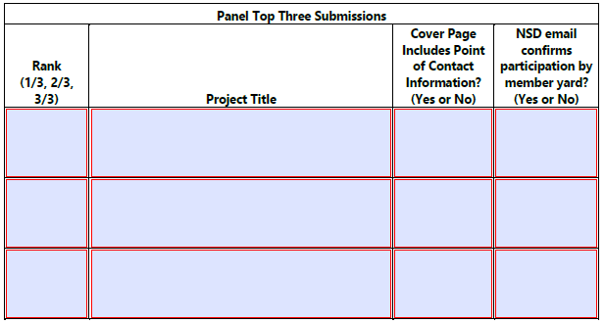

Joint Panel Submission: : Type the complete title of the Joint Panel Submission in the “Project Title” box.
Include a Yes or No answer to “Cover Page Includes Point of Contact Information?” and “NSD email confirms participation by member yard?”

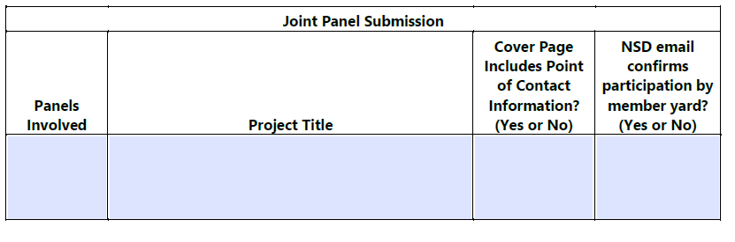
Attach Files: Click the yellow “Attach Files” button, the following pop-up instruction box appears: 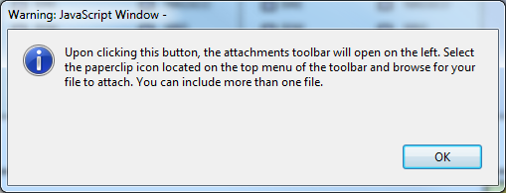

Click the “OK” button for the attachments toolbar to open on the left-hand side of the Submission Form:

Click on the paperclip icon to attach files:

Browse to the file to be attached and click “Open”. Repeat previous two steps for additional white papers. Maximum three individual white papers per Panel. Lead Panel Chair for any Joint Panel white papers attach those here as well.

Did the NSRP Member Shipyard Vote?: Choose one box to check next to each yard.
Yard Voted: Yes, the member shipyard cast a vote.
Yard Abstained: The member shipyard abstained from a vote (i.e. representative informs panel chair that the shipyard abstains and votes neither yes nor no).
Yard Did Not Vote: The member shipyard did not cast a vote. (i.e. representative provides no indication of any kind to the panel chair.)

NOTE: This section is used to indicate whether an NSRP member shipyard participated in the vote. It does not represent whether the member shipyard voted for or against a specific project.

Did the NSRP Member Shipyard Vote?
Shipyard | Yard Voted | Yard Abstained | Yard Did Not Vote
Austal USA
BAE Systems Ship Repair
Bath Iron Works
Conrad Shipyard
Electric Boat
Fincantieri Marinette Marine
Ingalls Shipbuilding
NASSCO
Newport News Shipbuilding
VT Halter
Vigor
*NOTE: This section is used to indicate whether an NSRP member shipyard participated in the vote. It does not represent whether the member shipyard voted for or against a specific project.*

Comments: Enter any explanation for why a member yard abstained, if provided.
Enter which yards plan to implement any technology/processes developed or utilize the results.
Submit: Certify the information on the form and submit white papers to the ATI NSRP Staff, click the blue “Submit” button:
Make sure “Desktop Email Application” is selected and click “OK”.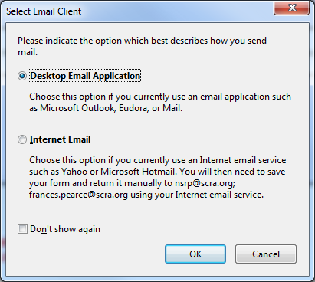
A pre-formatted and pre-addressed email will open, click “Send” to complete the submission process and submit the white papers to the NSRP Executive Director staff.
