Proposal
Preparation Kit
Version: 14.0 dated April 01, 2020
(Replaces Version 13.0 dated March 25, 2019)

MISSION
- The mission of the National Shipbuilding Research Program (NSRP) is to reduce the total ownership cost and improve the capabilities of both United States Government and U. S.-flag commercial ships.

- The Program accomplishes this mission by providing a collaborative framework to manage, focus, develop, and share research and development and leverage best practices in shipbuilding and ship repair.

TABLE OF CONTENTS
1.0 Introduction 3
2.0 Definitions 3
3.0 General Instructions 4
4.0 Summary Proposal 6
4.1 Cover Page 6
4.2 Technical Summary 6
4.2.1 Synopsis 7
4.2.2 Problem to be addressed/General Objectives 7
4.2.3 Technical Approach 7
4.2.4 Current State and Relevant Efforts 8
4.2.5 People and Organizational Impacts 9
4.2.6 Technology Readiness Level (if applicable) 9
4.3 Business Case 9
4.4 Technology Transfer & Implementation (Commitment to Implement & Willingness to Share) 11
4.5 Attachment 1 – Supporting Tables 13
4.5.1 Participants 13
4.5.2 Summary Work Statement and Funding Plan 13
4.5.3 Key Deliverables 13
4.5.4 Total Man-hour Summary 13
4.5.5 Total Material/Equipment Summary 13
4.5.6 Property To Be Acquired or Developed 14
4.5.7 Risk Management 14
4.5.8 Metrics/Benefit Realization 14
4.5.9 Cost Summary 15
4.5.9.1 Program Funding 15
4.5.9.2 Cost Share 15
4.5.9.3 Public Sector-Participant-Provided Funding 16
4.5.10 Financial Viability 16
APPENDIX A – NSRP Summary Proposal Checklist 18
APPENDIX B – Summary Proposal Supporting Tables 19
APPENDIX C – Research Annoucement Process Overview 28
APPENDIX D – Proposal Evaluation, Selection, And Award 32
APPENDIX E – Proposal Evaluation Factors 36
APPENDIX F – Implementation Risk 41
APPENDIX G – Proposal Submission Process 43

1.0 INTRODUCTION
This National Shipbuilding Research Program Advanced Shipbuilding Enterprise (NSRP ASE, hereafter “NSRP”) Proposal Preparation Kit (PPK) contains background material, specific instructions, and guidance for the preparation of proposals for the Research Announcement solicitation 25 March, 2020 (hereafter the “RA”). This PPK has been prepared in an effort to provide prospective offerors with clear proposal instructions and important aspects of the RA proposal submittal and proposal evaluation process used by NSRP. This PPK replaces, in its entirety, PPK version 13.0 dated March 25, 2019.
Questions regarding this document should be referred to:
Mr. Scott Leecock, Contracting
NSRP Program Administrator
Advanced Technology International (ATI)
315 Sigma Drive
Summerville, SC 29486
scott.leecock@ati.org

National Shipbuilding Research Program Overview
The National Shipbuilding Research Program’s mission is to reduce the total ownership cost and improve the capabilities of both United States Government and U.S flag commercial ships. NSRP achieves this mission by providing a collaborative framework to manage, focus, develop, and share research and development and leverage best practices in shipbuilding and ship repair. The total ownership cost includes all elements of the ship lifecycle including the costs of design, construction, maintenance and repair, technology refresh/insertion, operation and sustainment, and disposal. The NSRP’s Government impact is primarily on U. S. Navy ships, but the program is also intended to benefit other Government organizations such as the U.S. Coast Guard (USCG), National Oceanic and Atmospheric Administration (NOAA), Maritime Administration (MARAD), Military Sealift Command (MSC), and Army Corps of Engineers (ACoE). The NSRP considers unmanned and optionally manned vessels to be types of ships fully within the mission scope. The NSRP’s mission equally includes reducing the total ownership costs of and delivering capability improvements to U. S.-flag commercial ships

2.0 Definitions
NSRP – National Shipbuilding Research Program.
Project Participant/Program Participant – Collaboration members, other industry Primes, or team members that participate on projects funded under this program.
Public Sector Project Participant – project participants from Federal government agencies such as NAVSEA and subordinate commands such as Naval shipyards, Naval Warfare Center elements, Regional Maintenance Centers, government labs, etc. “Public sector” also includes state and local government agencies.
Shipyard - means an organization that primarily builds (new construction) or repairs ships, boats, barges, unmanned surface or undersea vessels, and other watercraft. This organization owns or leases marine facilities that are capable of fabricating and assembling these vessel types (building ways, erection platens, launching facilities from docks, to railways, to mobile lifts like Travelifts ©, etc.). Repair organizations have facilities for removing vessels from the water and/or pier-/wharf-side in-water repairs for depot-level maintenance. A “shipyard” will possess its own capabilities (or be able to subcontract) for all typical shipbuilding/ship repair trades (shipfitters, welders, inside and outside machinists, electricians, electronics/mission systems technicians, painters, joiner workers, etc.). “Shipyard” includes all public Naval Shipyards and all organizations doing work under Department of Labor 2017 North American Industry Classification System (NAICS 2017) code 336600 “Ship and Boat Building”, which includes maintenance and repair occupations.
Subcontractor/Consultants – an organization that provides a contracted service and does not contribute cost share.
Team Member – an organization that potentially benefits from the proposed R&D and contributes cost share.

3.0 GENERAL INSTRUCTIONS
A Summary Proposal submitted in response to an NSRP RA posted on the NSRP website or System for Acquisition Management, Beta.SAM.Gov (formerly Federal Business Opportunities (FedBizOpps)), is the primary vehicle available for receiving consideration for award. The Summary Proposal shall stand on its own merit. For the purposes of this document, the terms “proposal” and “Summary Proposal” are used interchangeably.
A list of all the requirements contained in this document can be found in Appendix A.
Offerors are strongly encouraged to use the checklist to ensure proposals are submitted in accordance with NSRP requirements.

The Summary Proposal should be prepared, providing straightforward, concise delineation of capabilities necessary to perform the work being proposed. All research projects proposed under this program shall be subject to the terms and conditions of the NSRP Base Task Order Agreement (TOA). The Base TOA must be executed between the Program Administrator and the offeror prior to award of individual project Task Orders. The following terms from the Base TOA apply to all project Task Orders and are non-negotiable:

- Unless otherwise specifically negotiated and approved, the Government will obtain Government Purpose Rights to all intellectual property (IP) funded by the Program and developed by the offeror and its lower-tier subcontractors under the NSRP Program, including IP developed using offeror cost share sources. Any request by the offeror, project team member or lower-tier subcontractor for specially-negotiated rights other than Government Purpose Rights, must be disclosed in the Summary Proposal for consideration and approval.

- Prior to award, the offeror is responsible for determining a team member/subcontractor’s qualification and compliance with National Policies in accordance with Article XII of the Base Task Order Agreement (TOA).

Proposals containing data that is not to be disclosed to the public for any purpose, or used by the NSRP Program except for evaluation purposes, shall include the following statement on their title pages:
The proposal includes data that shall not be disclosed outside the Program Administrator [including the Technical Evaluation Review Panel (TERP), ECB, Major Initiative Teams, Program Technical Representatives, Blue Ribbon Panel (BRP), and any attendees at an ECB project selection/approval meeting] and the Government; it shall not be duplicated, used, or disclosed, in whole or in part, for any purpose other than to evaluate this proposal and negotiate any subsequent Task Order award. If, however, a Task Order is awarded to this offeror as a result of, or in connection with, the submission of these data, the Program Administrator and the Government shall have the right to duplicate, use, or disclose these data to the extent provided in the resulting Task Order. If selected for award, the proposal can be used by the Program Administrator staff, Major Initiative Team personnel, and Program Technical Representatives for purposes of project management and award negotiation. This restriction does not limit the Program Administrator’s nor the Government's right to use the information contained in these data if they are obtained from another source without restriction. The data subject to this restriction are contained on sheets (insert page numbers or otherwise identify the sheets).
Each restricted data sheet should be marked as follows:
Use or disclosure of data contained on this sheet is subject to the restriction on the title page of this proposal or quotation.
The Summary Proposal shall be:

- Page limit – The Summary Proposal shall be no more than 10 single-spaced, single-sided pages measuring 8.5 by 11 inches. The page limitation is exclusive of the cover page and required attachments.
- Font – The Summary Proposal shall be in a font that is 10 point size or larger. Smaller type may be used in figures and tables, but not less than 8 point size, and must be clearly legible.
- Margins – The Summary Proposal shall have margins at least 1 inch on all sides (top, bottom, left, and right).
Offerors are strongly encouraged to build their Summary Proposal around the underlying business case that demonstrates value to the Government stakeholder(s) and industry. To that end, past experience indicates that proposal preparation will best begin with thorough consideration of the business case logic.

DO NOT SUBMIT ANY CLASSIFIED INFORMATION.

4.0 SUMMARY PROPOSAL
To ensure proper consideration, the Summary Proposal format shown below is mandatory.

4.1 Cover Page
A cover page is required on the Summary Proposal, and shall include the following information and statements:
Name and address of offeror
Title of Proposal
Summary Proposal
Team Members / Subcontractors / Project Participants
(Identify each organization or person who will be part of the project team)

The following statement: “This proposal is submitted pursuant to (cite the Research Announcement title, reference number, and date)”.
Duration of effort: (in months)
Names, telephone numbers, and email addresses of the technical point of contact and contractual point of contact (if different), along with an alternate for each, who may be contacted for evaluation or negotiation purposes.
The following statement: “Offeror certifies that, if selected for award, the offeror will provide a full Cost Proposal in accordance with the NSRP Cost Guidelines document dated (date) and abide by the terms and conditions of the NSRP Base Task Order Agreement, in its entirety.”
The following statement: “Offeror certifies that, if selected for award, the Government will obtain Government Purpose Rights, as defined in the Base Task Order Agreement, to all intellectual property (IP) funded by the Program and developed by the offeror, team members and its lower-tier subcontractors under the NSRP Program, including IP developed using offeror cost share sources. Any request for specially negotiated rights other than Government Purpose Rights will be disclosed in the following summary proposal for consideration and approval. If not specified and requested in this summary proposal, the offeror agrees that Government Purpose Rights, as defined in the NSRP Base Task Order, will be required.”
The following statement: IP assertions associated with this summary proposal are provided in Table 6.
The proprietary data disclosure statement, when proprietary data is included.
The statement: “Technical content from this summary proposal may be used by the NSRP Program and the NSRP Executive Control Board in preparing future NSRP Strategic Investment Plans, Technology Investment Plans and Research Announcements.”
Date of submission and signature of an official authorized to obligate the institution contractually. If the offeror is an NSRP-member shipyard, the ECB member’s signature must also be included on the cover page.

4.2 Technical Summary
The Technical Summary of the proposal shall briefly and concisely present the important aspects of the proposal to evaluators. The summary shall present an organized description of the work to be accomplished, without the technical details, such that the reader can grasp the core concepts of the proposed project.

4.2.1 Synopsis
This section provides, briefly (no more than 2-3 sentences), a description of what the project team proposes to do, and what the effort will produce.

4.2.2 Problem to be addressed/General Objectives
This section provides a summary of what problem the proposed project addresses. The following questions should be answered:

- What problem is being addressed that is within the scope of this RA and/or the current Technology Investment Plan (TIP)? What area of emphasis is this in the TIP? The offeror shall list the specific interest area(s) of the TIP being addressed to the fifth level of indenture (i.e., 7.X.X.X.X).
- What fundamental difference(s) in the U.S. shipbuilding and repair industry will be enabled by the successful completion of the proposed project?
- Provide evidence of Government stakeholders’ (e.g., Navy Program Executive Office, platform program manager, Technical Warrant Holder (TWH), Supervisor of Shipbuilding) or other stakeholders’ support/agreement that this problem area needs to be addressed through an NSRP-funded R&D project. An email from the government stakeholder indicating support is sufficient evidence.

4.2.3 Technical Approach
This section provides a summary of how the project team will approach the problem, and the key innovation(s) expected from the project. Provide sufficient technical detail and analysis to support the technical approach being proposed. Clearly identify the core of the intended approach. It is not appropriate to simply address a variety of possible solutions to the technology problems.

Provide the following information:
- Scope, including summary of technical/process issues being addressed
- Principle(s) of intended approach
If the proposed effort is follow-on work to a previously-funded effort, whether NSRP or any other funding source, include that project’s program and identification number, a brief synopsis of what was accomplished, the previous project’s results, and how the proposed effort builds upon previous work.
- Technical detail and analysis to support approach being proposed.
- Project objectives that include:
- Vision of what will be achieved
- Solutions the effort will produce
- Benefit metrics
- Brief description of major tasks, by task number, to permit correlation with the labor hours and Material Cost Summary table appearing later in the Summary Proposal (Appendix B)
- If there is more than one organization involved in the technical approach, explain how they will interact with each other (e.g., relationships, inter-dependencies).
- Identify engagement with and commitments from Navy or other government stakeholders to date, as well as any planned engagement before and during project execution. Specifically note portion(s) of the proposal statement of work that are assigned to Government organizations for performance. Labor costs for Government “working capital-funded” organizations shall be identified in the appropriate attachments to the proposal.
  - Parties should contact the NAVSEA NSRP Program Engineer, Mr. Howard Franklin, at howard.l.franklin@navy.mil or (202) 781-2171 for early coordination.

If the technology requires additional development, qualification, or sustainment after the project is complete, includes plans or structure for completing the necessary work to fully support implementation. This should be in the form of a roadmap.

4.2.4 Current State and Relevant Efforts
Each proposal must include a discussion of what technology is currently available in the proposed area.
Discussions should include, where applicable:
- Results of/evidence of the current state of the art/literature searches and how your approach compares to other possible approaches including a search of current and recent ONR ManTech project books to prevent duplication of efforts.
- Connections to ongoing or past projects in the general technology area/process being addressed.
- Identification of funding from other Government sources (to include but not limited to SBIR and ManTech) for a current effort(s) or one being proposed within the next 12 months that is similar to the work being proposed.

Offerors are encouraged to review the NSRP Project Portfolio for project results.

4.2.5 People and Organizational Impacts
Describe the project's approach to addressing people and organizational impacts, including how, in the context of performing this project:
- Organizational change/cultural change will be accommodated
- Current human resource functions will be impacted
- Workforce Development (education/training) will be addressed

4.2.6 Technology Readiness Level (if applicable)
Identify the starting Technology Readiness Level (TRL) of the proposed process or technology, and state the predicted TRL at successful project completion. Use the U.S. DoD definitions found in the April 2011 Technology Readiness Assessment Guidance.

4.3 Business Case
This section describes the business opportunity that the project will address. Include likely products, target markets, potential customers (e.g., specific Navy, other U.S. or state government agencies, or commercial interests), size of market opportunity, avenues for broad diffusion of benefits, and rationale for your choices. The strength of the business case is a key discriminator between proposals.
Offerors are strongly encouraged to build their proposal around the underlying business case.
Any business case requires adequate justification. The proposal must discuss the business requirement that the proposed new technology and/or business process will address, and clearly demonstrate that there is a need for the technology/process. Discuss the breadth of applicability to the shipbuilding and ship repair industry, the level and nature of benefit to the Navy, other Government agencies, and commercial businesses; the potential for lead-time and cycle-time reduction; the life of the product/technology in the marketplace (years); and any synergy with other operations, businesses, research, and programs. The proposal should identify why NSRP support is needed and what difference NSRP funding is expected to make in terms of what will be accomplished. As applicable, discuss benefits to be realized in the following areas and, where able, a rough-order-of-magnitude measure of those benefits:
- Labor (Direct & Indirect)
- Lifecycle Operations and Support, including maintenance
- Rework
- Material & Supplies
- Cost Avoidance
- Scrap
- Schedule
- Time Value of Money
- Services
- Additional Income
- Equipment
- Increased Technology Readiness Level (TRL)
- Inventory
- Work in Progress (WIP)
- Other

Proposals shall identify project metrics, including a plan to realize the benefits from achieving project goals. Describe metrics applicable to the project that will measure the benefit of the proposed project end-state compared to the as-is condition, and the means by which the project team will collect those metrics during the term of the agreement. Project metrics should logically follow from, and act to validate, the underlying business case. Actual benefits realized for the indicated metrics will be included in project reports.
In order to provide for a sound, strong business case, projects must also be well-defined and quantified so that a ROI can be calculated. The metrics discussion shall include project costs (both program funds and cost share, listed separately), estimated implementation cost, and predicted cost reductions to be realized through implementation of successful project results. Note that “cost reduction” includes both actual savings and cost avoidance, both immediate and future.
Predicted cost reductions are to be expressed in dollars, and should be based on well-defined metrics that will demonstrate a quantifiable ROI. Where exact numbers are not available, the project team should derive reasonable estimates by making—and explaining—assumptions based on historical cost information, past experience, and/or comparisons to similar innovations/processes. If possible, indicate the time period or number of hulls the savings estimate is based upon (e.g., per large surface combatant, per year, over 5 years). If applicable, generic data may be used in lieu of actual information considered to be company-proprietary. The basis and source of cost information shall be included.
A format and example for listing cost and cost reduction information from which ROI can be calculated are provided in the following table:

Inclusion of this information is mandatory.
Project Cost – [Name of Project]
Program Funding |  |  | $1,000,000
Cost Share |  |  | $1,000,000
Public-Sector Participant-Provided Funding |  |  | $0
TOTAL PROJECT COST  SAMPLE |  |  | $2,000,000
Implementation Cost Estimate– [Labor, Materials, Training, etc.]
Project Team Shipyards (per yard) |  |  | $10,000
Other Shipyards (per yard) |  |  | $100,000
Cost Reduction Forecast* [Savings & Cost Avoidance, Immediate & Future)
Cost Category | As-Is Baseline | Post-Implementation
Labor
- 30% reduced welding hours per platform | $10,000,000 | $7,000,000
- 75% reduced re-work hours per platform | $4,000,000 | $1,000,000
Materials
- 20% reduced welding consumables | $1,000,000 | $800,000
- 5% reduced steel plate | $100,000,000 | $95,000,000
TOTALS | $115,000,000 | $103,800,000
TOTAL COST REDUCTION | $11,200,000

4.4 Technology Transfer & Implementation (Commitment to Implement & Willingness to Share)
NOTE: For projects ultimately selected by the NSRP Executive Control Board, a detailed Technology Transfer and Implementation Plan must be submitted and approved prior to execution of a project Task Order. The Technology Transfer and Implementation Guide is available on the NSRP website to aid in preparing this portion of the proposal, as well as developing an actual Technology Transfer and Implementation Plan.
Provide an overview of the project transition/implementation strategy and stakeholders involved (Industry, Government, and/or Academia). In so doing, include the following information for both the period of project performance and for any subsequent implementation period:
- Description of the plan for industry dissemination of project developments
- Proposed presentations, demonstrations, pilots, project documentation, training, and prototypes, as well as any other technology transfer activities.
- The extent deliverables identified in the Statement of Work will be made available to industry
- The impact any proprietary material/information will have on the ability to conduct effective technology transfer.
- Discussion regarding the potential use of training material. This element should address required training for implementation within the participating shipyards, industry at large, shipboard operations and maintenance personnel and training/educational institutions.
- Previous and/or planned engagement with government (e.g., Navy Program Executive Office, platform program manager, TWH, Supervisor of Shipbuilding, naval shipyards) or other stakeholders to ensure buy-in and facilitate transition of project results to industry; and methods by which stakeholder commitment levels will be assessed during project execution. Include a statement describing any Navy TWH action required (e.g., specification or standards updates) to facilitate project implementation. If there is no Navy or Government stakeholder involvement, provide an explanation as to why not. (Contact information for some Navy stakeholders can be requested from NSRP.)
  - Parties should contact the NAVSEA NSRP Program Engineer, Mr. Howard Franklin, at howard.l.franklin@navy.mil or (202) 781-2171 for early coordination.
- Specific plans for implementation within the proposing shipyards, including evidence of senior management support.

Offerors are required in this section to include an identification of specific factors that pose a risk to successful implementation of project results. Please see Appendix F for more detailed instructions.
The rigor and complexity of the implementation approach and technology transfer approach should be commensurate with the nature and scope of the project. Offerors are cautioned, however, that failure to include discussions of both the implementation approach and the technology transfer approach may cause the proposal to be rejected during initial screening.

4.5 Attachment 1 – Supporting Tables
Attachment 1 will contain the tables discussed in the following sub-sections. Attachment 1 is not included in the proposal page-count limitation.

4.5.1 Participants
Provide as Table 1 in Attachment 1 a summary table that identifies each intended project participant, their role and key contributions to the project. (See Appendix B) Formal letters of commitment will not be required with the Summary Proposal. Those proposals that survive the down-select process to the Blue Ribbon Panel will be required to provide a formal letter of commitment from all funded or cost-sharing project participants to ATI prior to Blue Ribbon Panel. For Government participants, an email indicating commitment will suffice.
NSRP strongly encourages diverse project team composition, which include multiple shipyards, small businesses, academia and Government.
For projects with fewer than two (2) shipyard participants, an explanation for why only one yard is involved in the effort is required. Also include a short description of how the proposed team will ensure the project results are applicable to the broadest possible portion of the shipbuilding and ship repair industry.

4.5.2 Summary Work Statement and Funding Plan
Provide as Table 2 in Attachment 1 a concise summary of the project schedule, and cost information. (See Appendix B)

4.5.3 Key Deliverables
Provide as Table 3 in Attachment 1 a summary table that indicates the key deliverables. (See Appendix B)

4.5.4 Total Man-hour Summary
Provide as Table 4 in Attachment 1 a summary table of the total estimated man-hours (NSRP-funded and cost-shared, combined), broken down by project participant and major task. (See Appendix B)

4.5.5 Total Material/Equipment Summary
Provide as Table 5A in Attachment 1 a complete list of all material/equipment (NSRP-funded and cost-shared, combined) to be purchased in support of the project. This list should include items to be proposed by the Offeror, Team Members, and Subcontractors/Consultants. Include a description of each item of material or equipment, the quantity, the price per item, how the cost was derived (engineering estimate, past purchase, vendor quote, etc.), and how it will be used to support the project. The information in Table 5A, to include the proposed material and equipment items and the total proposed cost, must be consistent with information on material and equipment in the Cost Summary (Table 9).

For the purposes of this guidance, applicable items for Tables 5A includes Material, Special Test Equipment, Special Tooling, and Plant Equipment, defined below:
a. Material - property that may be incorporated into or attached to a deliverable end item or that may be consumed or expended in performing a contract. It includes assemblies, components, parts, raw and processed materials, and small tools and supplies that may be consumed in normal use in performing the proposed scope of work. Material/Supplies should be proposed separately from equipment.
b. Special Test Equipment - either single or multi-purpose integrated test units engineered, designed, fabricated, or modified to accomplish special purpose testing in performing the proposed scope of work. It consists of items or assemblies of equipment including standard or general purpose items or components that are interconnected and interdependent so as to become a new functional entity for special testing purposes.
c. Special Tooling - jigs, dies, fixtures, molds, patterns, taps, gauges, and all components of these items, including foundations and similar improvements necessary for installing special test equipment, and which are of such a specialized nature that without substantial modification or alteration their use is limited to the development or production of particular supplies or parts thereof or to the performance of particular services.
d. Plant Equipment - personal property of a capital nature (including equipment, machine tools, test equipment, furniture, vehicles, and accessory and auxiliary items) for use in manufacturing supplies, in performing services, or for any administrative or general plant purpose. It does not include special tooling or special test equipment.

4.5.6 Property To Be Acquired or Developed
Provide as Table 5B a list of any items that will be acquired or developed during the project and will remain as tangible property after the project is completed. This does not include material consumed during the project. All such property and its proposed disposition will be reviewed by NAVSEA during the source selection process. Such property and its ultimate disposition is subject to NAVSEA approval prior to project award.

4.5.7 Risk Management
Provide as Table 7 in Attachment 1 a matrix that identifies, by risk area, specific technical, schedule and cost risks that might be anticipated, and the intended steps for avoiding or mitigating those risks. (See Appendix B) Use this section to demonstrate that you understand the significant risks and have a plan for mitigating them.

4.5.8 Metrics/BENEFIT REALIZATION
Provide as Table 8 in Attachment 1 the performance improvement metrics that will be developed for the project. (See Appendix B)

4.5.9 Cost Summary
The objective of the Cost Summary is to provide sufficient evidence with which evaluators can make an initial determination that the proposed cost is realistic, relative to the proposed work.
IMPORTANT: For projects that are ultimately selected by the NSRP Executive Control Board, a full cost proposal must be submitted, fully analyzed by ATI Contracts staff, and found to be acceptable. The full Cost Proposal funded value should not exceed the initial Cost Summary by more than 10%. The full Cost Proposal cost share contribution value must meet the initial Cost Summary percentage. If either of these restrictions are not met, the proposal will be referred back to the ECB for disposition, which could include de-selection. Full details on the required full content and format are available on the NSRP website.
Provide as Table 9 in Attachment 1 a table summarizing the following (See Appendix B):

4.5.9.1 Program Funding
A listing of proposed program-provided funding amounts, broken down by cost element (e.g., labor, travel, materials, team members). Any indirect costs/burdens associated with the proposed cost elements must be included in the cost estimate.

4.5.9.2 Cost Share
All proposed cost share must be either:
- Direct Project R&D or administration of the same project OR
- Program cost share, related to other execution of the NSRP Program, concurrent with the period of performance of the specific RA project

A listing of proposed cost share amounts, broken down by contributing organization and indicating the associated cost share categories. Cost share categories are as follows:
- Cash (including donations from state or local governments)
- Labor costs (including labor-related fringe benefits)
- Expenses associated with allowable labor cost categories that are not billed directly to program funds
- Independent research and development (IR&D)
- Overhead (excluding labor-related fringe benefits)
- General & administrative (G&A) services
- Manufacturing and production engineering (M&PE)
- Implementation costs within the period of performance of the project
- In-Kind Cost Share, defined as the reasonable value of equipment, materials, or other property used in the performance of the Statement of Work. In-kind contributions are sometimes hard to value (such as space or use of equipment, and intellectual property). The in-kind value of equipment (including software) cannot exceed its fair market value and must be prorated according to the share of its total use dedicated to carrying out the project. The in-kind value of space (including land or buildings) cannot exceed its fair market value and must be prorated according to the share of its total use dedicated to carrying out the project.

A general test for determining whether a cost qualifies and the amount to be considered for an in-kind transaction follows:
- Is the resource under the control of or used by a Program Participant in conducting project research? If so, does it actually help with the project; is it germane to the overall statement of work?
- Does the contribution represent a real opportunity cost to the Program Participant, either now or in the future?
- What is the fair market value of the resource?
- Intellectual property owned by the private sector (market value)
- Space (land or buildings)

For projects proposed with less than 50% cost share, a detailed rationale is required for why the goal could not be achieved, and/or why this cost share deficit is appropriate based on factors such as project team composition, technology risk, implementation mechanism, etc.
Note: The full Cost Proposal will require a breakdown of cost share based on its origin: Federal or Non-Federal. Details on providing this breakdown are provided in the NSRP Cost Proposal Guidelines, which are located on the NSRP website.

4.5.9.3 Public Sector-Participant-Provided Funding
Funding provided to the project effort by Federal, state, or local public sector participants cannot be counted as cost share. Include this funding in the separate section provided in Table 9. This does not include funding provided by NSRP for a public sector participant.

4.5.10 Financial Viability
The offeror may provide its current Dun and Bradstreet financial report (in accordance with all applicable copyright requirements). Alternatively, the required financial and employment information from the most recent preceding three years (or for the number of years the organization has existed, if less than three years) can be provided as Table 10 in Attachment 1. (See Appendix B)

Appendices

APPENDIX a – NSRP SUMMARY PROPOSAL CHECKLIST
Offerors are encouraged to utilize the checklist to ensure that all items listed below are included or adhered to in all proposals submitted to the NSRP Program.

Failure to submit the required documents, provide narrative sections, complete the required tables and adhere to the format requirements may result in the proposal being disqualified.
No. | Item | Included in Submission?
- 1. | - One electronic copy of a Summary Proposal
- 2. | - Summary Proposal page count does not exceed 10 (excluding Cover Page and Attachments)
- 3. | - Format requirements (font size, line spacing, margins, . . . ) are in accordance with the published guidelines
- 4. | - Cover Page identifies Offeror and Team Members and Subcontractors
- 5. | - Offeror certifies on the Cover Page that, if selected for award, the offeror will provide a Full Cost Proposal in accordance with the NSRP Cost Guidelines Document Version 3.0 dated March 24, 2020 and by the terms and conditions of the NSRP ASE Base Task Order Agreement Version 03 dated October 23, 2018.
- 6. | - Offeror certifies on the Cover Page that, if selected for award, the Government will obtain Government Purpose Rights to all intellectual property (IP) developed under the NSRP Program including IP developed using cost share sources. Any request for specially negotiated rights other than Government Purpose Rights is included in the Summary Proposal for consideration and approval.
- 7. | - Offeror provides permission to use a technical summary of the proposal in preparing future SIP updates, TIP updates, and research announcements.
- 8. | - The following Narrative Sections are to be included in the Summary Proposal:
 | - Synopsis
 | - Problem To Be Addressed/General Objectives
 | - Technical Approach
 | - Current State and Relevant Efforts
 | - People and Organizational Impacts
 | - Technology Readiness Level (if applicable)
 | - Business Case with ROI Discussion
 | - Technology Transfer and Implementation (including Implementation Risk factors)
9. | The following Tables are to be included in Attachment 1 to the Summary Proposal:
 | - Participants (including rationale for a project team with less than 2 shipyards, if applicable)
 | - Summary Work Statement and Funding Plan
 | - Key Deliverables/Go-No Go Criteria
 | - Total Man-hour Summary (NSRP-funded and Cost-Shared)
 | - Total Material/Equipment Summary (NSRP-funded and Cost-Shared)
 | - Property to be Acquired or Developed
 | - IP Assertions
 | - Risk Management
 | - Metrics/Benefit Realization
 | - Cost Summary (including rationale for proposing less than 50% cost share, if applicable)
 | - Financial Viability or Dun & Bradstreet Report
10. | Project period of performance is within RA instruction

APPENDIX B – SUMMARY PROPOSAL SUPPORTING TABLES
Completion of all the tables in this appendix are mandatory, and shall be submitted as Attachment 1 to the Summary Proposal.

Table 1 - Participants
Project Participants | Role and Key Contribution
Shipyard AAA
Company BBB
Organization CCC
Navy Laboratory DDD
Other
Include justification for having less than two (2) shipyard participants on the project team (if applicable).

Table 2 – Summary Work Statement and Funding Plan
Phase Number | 1 | 2 | Total
Phase Start Date | mm/dd/yyyy | mm/dd/yyyy
Phase Completion Date | mm/dd/yyyy | mm/dd/yyyy
Duration (Months) | mm/dd/yyyy | mm/dd/yyyy
NSRP Program Funding | $ | $ | $
Cost Share | $ | $ | $
Public Sector Participant Provided Funds | $ | $ | $
Note: Phases must be sequential, non-overlapping, and no longer than twelve (12) months each.

Table 3 – Key Deliverables ***EXAMPLE ONLY***
Key Deliverable
Key Deliverable (Major Payable Milestones) | - Nationwide survey and analysis of shipyard injury and illness trends  - An analysis of risk factors that contribute to leading causes of shipyard accidents, injuries and illness
Criteria for “Go/No-Go” Decision on Subsequent Phase | - Survey successfully completed  - Analysis documented and submitted  - Review of analysis indicates high quality

Table 4 – Total Man-Hour Summary (NSRP-Funded and Cost-Shared, combined)
Major Task # | Task Title | Participant 1  Man-Hours | Participant 2  Man-Hours | Participant 3  Man-Hours | Total  Man-Hours
1
2
3
…
Totals

Table 5A – Total Material/Equipment Summary (NSRP-Funded and Cost-Shared, combined)
Material Description | Quantity | Price per Unit | How was cost derived? | How will material/equipment be used to support project?

Table 5B –
Property to Be Acquired or Developed
Note: “Property” means any items that will be acquired or developed during the project and will remain as tangible personal property at the end of the project. It does not include material consumed during the project. All such property proposed will be reviewed by NAVSEA during the source selection process. Property valued at $50,000 or more and its disposition is subject to NAVSEA approval prior to project award.

Property Description | Quantity | Total Value | How was value determined? | What is proposed for property disposition at project end?

Table 6 – IP Assertions

The Offeror asserts for itself and all its team members/subcontractors/consultants/suppliers/persons identified below that the Government's rights to use, release, or disclose the following technical data or computer software should be restricted. Enter "None" in the first row when all data or software will be submitted without restrictions.
Technical Data/Computer Software to be Furnished with Restrictions¹ | Basis for Assertion² | Asserted Rights Category³ | Name of Offeror Asserting Restrictions⁴
Name or description of tech data or software | Developed at private expense | Limited | Company X

¹For technical data (other than computer software or documentation) pertaining to items components, or processes developed at private expense, identify both the deliverable technical data and each such item, component, or process. For computer software or computer software documentation, identify the software or documentation.

²Generally, development at private expense, either exclusively or partially, is the only basis for asserting restrictions. For technical data, other than computer software documentation, development refers to development of the item, component, or process to which the data pertain. The Government's rights in computer software documentation generally may not be restricted. For computer software, development refers to the software. Indicate whether development was accomplished exclusively or partially at private expense. If development was not accomplished at private expense, or for computer software documentation, enter the specific basis for asserting restrictions.

³Enter asserted rights category (e.g., government purpose license rights from a prior contract; rights in SBIR data generated under another contract; limited, restricted, or government purpose rights under this or a prior contract; or specially negotiated licenses).

⁴Corporation, individual, or other person, as appropriate.

Table 7 – Risk Management
Risk Area | Risk | Avoidance/Mitigation
Technical
Schedule
Cost

Table 8 – Metrics/Benefit Realization ***EXAMPLE ONLY***
Metric | “As-Is”  Baseline | Project  Goal | Delta | % Change  (+/-) | Tracking & Reporting Plan
Ship repair cycle time | 120 Days | 85 Days | 35 Days | -29% | Select a similar ship availability as baseline; document cycle time at the end of the job
Transaction cost for ________ | $700 | $125 | $575 | -82% | Report quarterly as process improvements are implemented
Parts in inventory | 20,000 | 12,000 | 8,000 | -40% | Set a monthly part reduction goal and assess each month; report quarterly the reduction and any changes to the plan to reach project goal
Technology Readiness Level | 4 – Component/ breadboard validation in laboratory environment | 7 – Prototype validation in operational environment |  |  | Demonstrate prototype of technology in shipyard production environment

Table 9 – Cost Summary
Program Funds
Funding Category | Description | Amount ($)
Offeror Labor
Offeror Travel
Team Members
(contributing cost share)
Subcontractors/Consultants
(not contributing cost share)
Public Sector Project Participant
Material
Equipment
Other Direct Cost
TOTAL PROGRAM FUNDS
Cost Share
Category | Contributing Organization | Amount ($)
TOTAL COST SHARE
Public Sector Participant Provided Funding
Category | Contributing Organization | Amount ($)
TOTAL PUBLIC SECTOR PARTICIPANT PROVIDED FUNDING
Include rationale for proposing less than 50% cost share (if applicable).
Note: DO NOT INCLUDE LABOR HOURS IN THIS PORTION – ONLY FUNDING AMOUNTS.

Table 9 – Cost Summary (Program Funding Section) ***EXAMPLE ONLY***
NSRP Program Funds
Funding Category | Description | Amount ($)
Offeror Labor | Engineering  Program Management  Manufacturing | $150,000
Offeror Travel | 6 trips to team meetings, technology transfer events | $10,000
Team Members  (contributing cost share) | Shipyard A | $100,000
 | Shipyard B | $50,000
 | Shipyard C | $50,000
 | Software R Us, Inc. (type of license/license fee) | $10,000
Subcontractors/Consultants  (not contributing cost share) | Technology Labs, Inc. | $15,000
 | University of Academia | $10,000
 | Lawyers R Us, LLC | $10,000
Public Sector Project Participant | N/A | $0,000
Material | Steel | $5,000
Equipment | Special Tooling | $1,000
Other Direct Cost | Meeting expenses | $5,000
TOTAL PROGRAM FUNDS |  | $416,000
Note: DO NOT INCLUDE LABOR HOURS IN THIS PORTION – ONLY FUNDING AMOUNTS.

Table 9 – Cost Summary (Cost Share Section) ***EXAMPLE ONLY***
Cost Share
Category | Contributing Organization | Amount ($)
Labor | (Offeror) | $150,000
Labor, Materials | Shipyard A | $100,000
Labor | Shipyard B | $50, 000
Use of software | Software R Us, Inc. (type of license/license fee) | $25,000
TOTAL COST SHARE |  | $325,000
Public Sector Participant Provided Funding
Category | Contributing Organization | Amount ($)
Labor | Naval Surface Warfare Center | $13,000
TOTAL PUBLIC SECTOR PARTICIPANT PROVIDED FUNDING |  | $13,000
TOTAL PROJECT COST |  | $753,000
TOTAL PROJECT COST MINUS PUBLIC SECTOR PROVIDED FUNDING |  | $740,000
Note: DO NOT INCLUDE LABOR HOURS IN THIS PORTION – ONLY FUNDING AMOUNTS.
Note: Ensure indirects/burdens are included in the respective estimates.

Table 10 – Financial Viability
 | Year T-3 | Year T-2 | Year T-1
Income Statement
Revenue
Annual Sales
Cost of Sales (Cost of Goods Sold)
R&D Expenditures
Net Income Before Taxes
Net Income
Balance Sheet
Total Assets
Cash and Cash Equivalents
Accounts Receivable
Total Liabilities
Loans and Leases Payable
Net Worth (Owner’s Equity)
Employment Information
Total Number of Full-Time Employees
Total Number of Part-Time Employees

For large companies with multiple divisions or business units, please clearly identify the reporting entity for which financial and employment information is being presented. Please provide data for the lowest level corporate entity for which such data are available, corresponding to the entity in which the proposed R&D project is to be performed. The information provided will be used as a consideration for determining qualified and responsible companies and eligibility for award and, as a source of information for determining if advanced payments will be approved for awarded projects.

APPENDIX C – RESEARCH ANNOUNCEMENT PROCESS OVERVIEW

Definition
Research Announcement (RA) solicitations provide a method of contracting for research and development (R&D) based on notices posted on the System for Award Management website, Beta.SAM.Gov (formerly Federal Business Opportunities (FedBizOpps). ) An RA is general in nature, identifying areas of research interest, providing the evaluation criteria for selecting proposals, and soliciting the participation of all offerors capable of satisfying the NSRP's needs. The RA method is used when meaningful proposals with varying technical/scientific approaches can be reasonably anticipated.

Purpose
RAs are used when the NSRP Program desires to solicit for new and creative solutions to problem statements and/or advances in knowledge, understanding, technology and state of the art. The NSRP Program generally states its objectives in terms of areas of need or interest rather than specific solutions or outcomes. RAs are used rather than formal Requests for Proposal (RFPs) because of their flexibility.

Characteristics
Characteristics of the NSRP RA process include the following:
- RAs encourage creative and unique ideas by giving offerors the flexibility to propose solutions to stated industry-wide problems.
- Offerors may respond to all or part of the areas of interest or problems in the announcement.
- The NSRP Program may choose to procure all or part of an offeror’s submission.
- The offeror defines and develops the Statement of Work (SOW).

Research Announcement Publication
The RA posted on Beta.SAM.Gov (formerly FedBizOpps) represents the official solicitation to prospective offerors of a potential NSRP Program acquisition. This posting will be paralleled by a posting on the NSRP website which will contain full and complete solicitation information.
An example RA may be available on the NSRP website throughout the year, even when there is no active solicitation, so that interested parties can evaluate future participation terms. An actual RA can be located on the Beta.SAM.Gov site (on the homepage, type “NSRP” in the “Keyword/Solicitation #” field, then click search), as well as on the NSRP website. The RA includes a point of contact who can provide additional assistance if needed. Potential offerors are encouraged to make contact with the listed individuals for possible clarifications via email. The following sections are intended to clarify those areas that usually generate the most questions from offerors.
Solicitation Revisions
Changes to the RA posted on Beta.SAM.Gov will only be made by publishing an amendment to the NSRP website. Amendments to an RA may be used to extend proposal due dates, clarify requirements, or change or modify existing minor technical requirements. A new RA may be issued and the original one canceled if the requirements change substantially. Offerors should carefully monitor Beta.SAM.Gov subsequent to the original posting, up to the time of the proposal due date. Any revision will appear in the same section of Beta.SAM.Gov as the original announcement.
Supplemental Information
Proposal Preparation Kit
The RA posted on Beta.SAM.Gov references a supplemental package (this document) that provides proposal instructions not included in the RA. The PPK provided herein is electronically published on the NSRP website and contains the instructions that offerors shall follow in order to submit a compliant, competitive proposal.

NSRP Website
Offerors are encouraged to browse the NSRP website to review general program information and additional solicitation details, including:
- Strategic Investment Plan
- Technology Investment Plan
- General Solicitation Information
- Solicitation Resources
- Sample Base Task Order Agreement
- Project Portfolio
- Benchmarking Efforts
- Project Plan Templates
- Project Implementation
Response Times
NSRP Research Announcements posted on Beta.SAM.Gov will indicate a proposal due date, which will also be prominently posted on the NSRP website. The due date/deadline will normally be no less than 60 days after the Beta.SAM.Gov posting. Proposals may be submitted any time between the date the RA is posted on Beta.SAM.Gov (formerly FedBizOpps) and the due date. The proposal due date can only be changed through a formal amendment of the solicitation posting.

The published proposal due date is firm. Except under exceptional circumstances as approved by the NSRP Executive Director, requests for extensions will not be considered.

Communication with the NSRP Program Office
Offerors may address questions via email to the Program Administrator's Contracts POC identified in the Research Announcement.

Multiple Awards

NSRP Research Announcements will normally result in multiple awards, generally made based on the quality of the proposals and availability of funding. Estimated total RA funding targets may be included in the Beta.SAM.Gov announcement, but individual project funding is not predetermined. Due to limited funding, NSRP reserves the right to limit awards under any topic and only proposals considered to be of superior quality will be funded. Single proposals that would consume most of the available program funding are less likely to be selected as the program traditionally selects a portfolio of projects for award. Occasionally, if feasible, NSRP may award only one or more parts of a proposal rather than acquiring the entire proposal.

Source Lists
Due to the nature of the RA solicitation, there is no “source list” or “bidders list.”

Discussions and Best and Final Offers
The program reserves the right to make awards without discussion. While award without discussion is anticipated and the use of Best and Final Offers (BAFOs) is not expected, NSRP reserves the right to negotiate the cost and scope of the proposed work with the offerors that have been selected to receive awards. For example, NSRP may request that the offeror delete from the scope of work a particular task that is deemed to be inappropriate or not a high priority for NSRP support.

Pre-Award Business Evaluation
Offerors should be aware that if the project is selected for award, the offeror shall conduct a pre-award Business Evaluation of all project team members, subcontractors, and consultants, to include:
- A determination that the Recipient is qualified
- A determination that the project funding is fair and reasonable
- A determination regarding the value and reasonableness of the Program Participant’s cost sharing contribution
  - Criteria used in deciding whether to accept a recipient's cost sharing
  - How to value cost sharing related to real property or equipment
  - The depreciation status of real property or equipment and acceptability as cost share
  - Acceptability of costs of prior research as cost share
  - Acceptability of intellectual property as cost share
  - How to value a Program Participant’s other contributions
- A determination of Fixed-Support, Expenditure-Based, or Hybrid Approach (discussed below)
- Method for Accounting, Payments, and Recovery of Funds

All documentation of the offeror’s pre-award evaluations must be maintained and available for review upon request.
Contractual Vehicle
The contractual vehicle used to fund the awards will be a project Task Order issued under the NSRP Base Task Order Agreement (TOA). Research conducted under the NSRP is intended to be partially funded by industry cost share; therefore the preferred Payment Method is “Expenditure Based”. Use of the “Fixed-Support” payment method is limited only to organizations whose accounting systems do not have the capability to collect and invoice based on actual costs incurred. If selected for award, organizations who request Fixed Support task orders will have to complete a Business System Information questionnaire that is subject to review and approval by the Program Administrator. Note: The payment method identified in the proposal may not be the type approved for award.

The most recent version of the Base TOA can be found on the NSRP website. Any modifications to the Base TOA will be posted on the NSRP website. Offerors should periodically visit the site for potential updates. Offerors are advised to contact the NSRP contractual POC listed in the RA if they have any questions on this requirement.

Government Furnished Equipment or Property
No government furnished equipment or property is expected in this program.

APPENDIX D – PROPOSAL EVALUTION, SELECTION, AND AWARD

General
Proposals submitted in response to RAs will be evaluated solely on the criteria posted in the solicitation, as amplified by available, published supplementary information. The proposal shall stand on its own as submitted.

The selection process for awards (as shown in Figure D-1) is a multi-step, source selection process based on the evaluation factors disclosed in the RA and further detailed in this PPK. Initial screening will be performed by the Program Administrator. A Technical Evaluation Review Panel (TERP) and a Blue Ribbon Panel (BRP) are used (as described herein) to ensure that all proposals receive fair and equitable consideration. This process uses a combination of scoring and subjective assessments. Proposals will be evaluated by a team of personnel drawn from industry, academia, and Government or as otherwise specified in the RA. In some cases, outside consultants may assist in proposal evaluation.

Late proposals will remain unopened, unless opened for identification purposes only, and will not be accepted. Upon completion of proposal evaluations, the BRP will recommend for award to the ECB, a best value portfolio that reflects the priorities set forth in the solicitation. Procedures require conflict-of-interest disclosures and non-disclosure agreements by all personnel handling proposals.

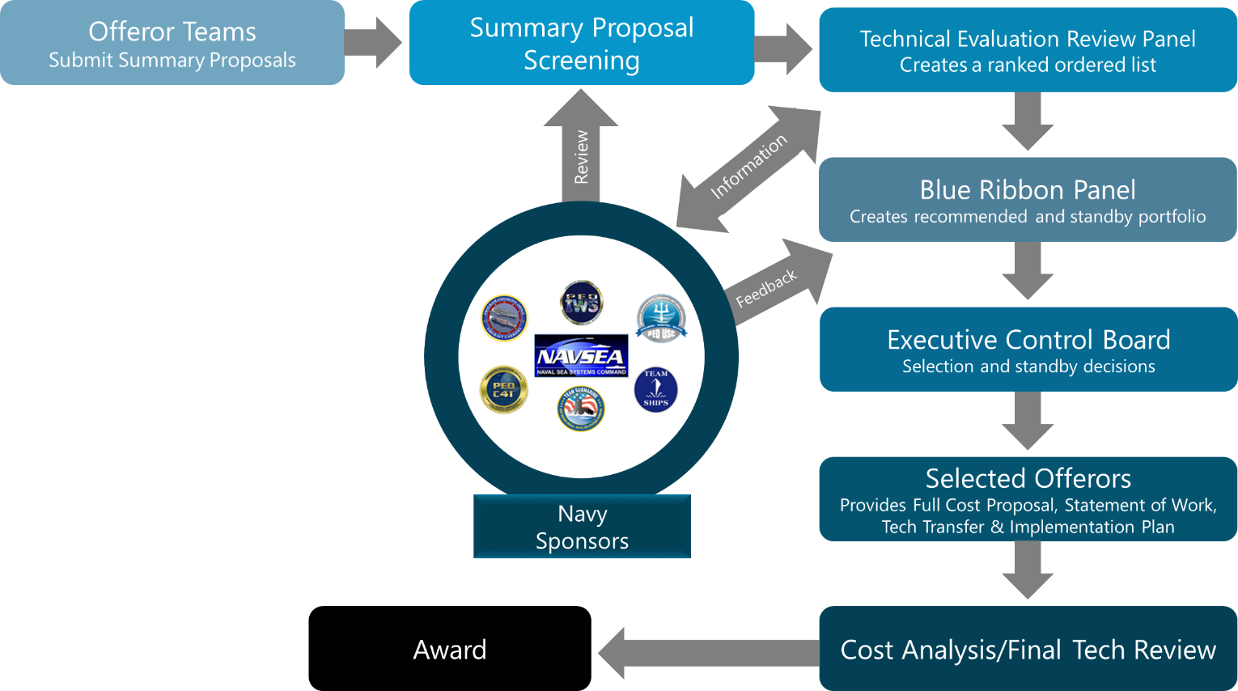
Figure D-1 – NSRP RA Project Submission and Selection Process

Initial Screening
In the first step, called “initial screening,” Summary Proposals are assessed for compliance with the proposal format and content requirements of the Research Announcement and PPK. Reasons a proposal may be eliminated at this stage include, but are not limited to:

- Proposal is deemed to have serious deficiencies in content,
- does not comply with key format and content requirements,
- is significantly overpriced or underpriced given the scope of the work, or
- does not meet the requirements set out in the Research Announcement and PPK.

The following items are primary reasons for non-compliance and elimination during screening:
- Summary Proposals without an affirmative response to the cover page certification of agreement to abide by the terms and conditions of the current NSRP Base Task Order Agreement
- Failure to include sufficient discussion on technology transfer and implementation plans
- Non-inclusion of mandatory tables and information
- Non-inclusion of ALL required summary cost information

The NSRP Proposal Checklist (Appendix A) is a key tool in ensuring compliance and successful initial screening.

Technical Review
In the second step, proposals are evaluated. The Technical Evaluation Review Panel (TERP), a group of third-party subject matter experts, (not employees of any NSRP member shipyard, other offerors, or affiliated with any proposal team) scores each Summary Proposal against pre-determined criteria using a numerical scale, assigns a final overall score, and rank-orders all proposals reviewed. The TERP also identifies specific strengths, weaknesses, omissions and risks, and makes recommendations for consideration by a Blue Ribbon Panel (BRP), composed of executive-level representatives with industry, Government and/or academic experience. The TERP may also recommend questions to be asked of the offerors to elicit clarifying information for the BRP to consider.

Proposals judged to have the highest merit based on the technical review normally receive further consideration by the BRP. A “Competitive Range” is established by the NSRP Executive Director after consideration of the technical evaluation, number of proposals, available funding, and feedback from any independent review of proposals by Government sponsors. In setting the Competitive Range, the Executive Director will determine location of a cut-off line in the TERP’s rank-ordered list, but will not re-order the rankings.

Evaluation of Competitive Range Proposals
In the final evaluation step, the Blue Ribbon Panel (BRP) performs an independent comparative assessment of Competitive Range proposals including a total, program-wide Best Value decision with appropriate tradeoff of technical and cost factors. The goal of this step is to ensure that the overall portfolio of selected projects is consistent with the priorities documented in the Research Announcement, Strategic Investment Plan, and Technology Investment Plan.

The Blue Ribbon Panel uses a portfolio management approach to ensure that the source selection process meets three important criteria: (1) a balanced portfolio, (2) coherence with the strategic direction of the industry, Government, and commercial customer base, and (3) a high return on investment.

Consideration includes the balance between high and low risk strategies, technology maturity and potential competitive impact, available funding, and strategic fit with the industry/Government/
commercial vision.

The NSRP Program is strategically targeted to support and expand existing business, drive new business, and broaden and deepen the industry’s development and implementation of advanced technology. The selection process emphasizes collaborative team projects that target the key, top-level cost drivers for the industry, yet provide funding for an appropriate number of projects to support NSRP mission execution.

Oral Review
For proposals in the Competitive Range, offerors will be required to attend an Oral Review with the Blue Ribbon Panel (BRP) at ATI offices in Summerville, South Carolina. Offerors may have up to four representatives present. The Oral Review focuses on technical and business questions. If the proposal involves less than two shipyards or less than 50% cost share, the representatives must be prepared to address the rationale for those conditions with the BRP. All offeror costs associated with participation in the Oral Review will be the responsibility of the offeror.

The exact date and time will be provided approximately two weeks in advance, and specific questions to be answered in writing by the offeror prior to the Oral Review will be provided shortly thereafter. At the Oral Review, the offeror will be expected to provide a 15-minute summary of the proposed project, and answer any other questions that might be raised by the BRP. The total time with the BRP should not exceed one hour.

At the time of the BRP, offerors will be required to provide a letter of commitment from each project team participant receiving program funding or providing cost share, to include any Government participant. These letters shall not exceed one page in length and must reflect commitment to the project (e.g., to perform project work, contribute cost share or other public-sector participant provided funding, etc.), and not discuss technical information. Letters of commitment must be signed by an individual who has signature authority to commit company or organization resources.

Use of Visual Aids at Oral Reviews
In order to enhance presentations, visual aids are allowed, with some restrictions listed below. All offerors are encouraged to bring visual aid(s) as appropriate, but it is not required.
- Acceptable visual aids can include: a physical model, photographs, graphical depictions of concepts or project flows, etc.
- Electronic presentations are limited to six (6) slides in Microsoft PowerPoint (1997 or later) format. Electronic presentations may include videos or animations, as long as the material is part of the presentation file (e.g., linking to the internet or requiring a separate program to display video is not allowed).
- If appropriate, each visual aid can be presented as a placard or poster (an easel will be provided) and/or as a one-page handout (without significant text beyond labeling necessary for clarity). Some members of the audience will be as far as 15 feet away, so poster-style visual aids need to avoid small font size, “busy” diagrams and glossy surfaces that reflect glare. 8.5” x 11” hard copies of poster-style visual aids are encouraged. Ten copies of each handout should be provided.
- Up to four different visual aids can be presented.
- Presenters are limited to 15 minutes with or without visual aids.
- The visual aids can be used during the presentation and/or during the Q&A process with the Blue Ribbon Panel.
- The visual aids need to be approved to be used at government briefings after being used for Blue Ribbon Panel briefings.
  - Submit electronic files in advance
  - Grant ATI approval for further distribution with restriction (public release)

The BRP-developed portfolio of recommended projects is then presented to the Executive Control Board (ECB) for approval, along with a prioritized list of technically-worthy projects for which funding is not presently available. The ECB may approve or reject the portfolio as a whole or—under well-defined procedural restrictions—amend the BRP’s recommendations on individual projects.

Award Process
For those proposals that are selected for award by the ECB, a Request for Proposal (RFP) will be issued within 2 business days after the selection meeting. A full cost proposal must be submitted to ATI for review and analysis by the NSRP Cost Analysis Panel within 30 days of receipt of the RFP. (Instructions for the cost proposal will be provided in a separate document.) A full Statement of Work and Technology Transfer & Implementation Plan must also be submitted within the same timeframe. Upon completion of the cost proposal evaluation, offerors will be issued and expected to execute the NSRP Base Task Order Agreement, if one is not already in place, and/or the individual project Task Order. It is anticipated that the cost proposal review and subsequent project Task Order execution should not take more than 30 calendar days. Awardees will have 10 business days from the date of receipt of the NSRP Base TOA to execute the agreement. Failure to have an executed NSRP Base Task Order Agreement may result in cancellation of the project.

APPENDIX E –Proposal EVALUATION FACTORS

Technical Evaluation Factors
The technical evaluation factors to be used in selecting proposals for award under this program include the Qualification Factors (i.e., the initial screening process described in Appendix C), the Critical Technical Factors, Discriminating Factors, and Cost Area and Evaluation Factors.

Critical Technical Factors
The TERP will evaluate and score the following four critical technical factors, discussed in more detail below: Strategic Fit and Leverage, Business Case, Innovation and Technical Merit, Technology Transfer and Industry Implementation.

- Strategic Fit and Leverage
Proposals will be evaluated for their fit with the NSRP mission statement, the Strategic Investment Plan (SIP), the Technology Investment Plan (TIP), and the Research Announcement. This factor considers the strategic impact of the project, the degree to which it addresses industry consensus priorities, and potential for leveraging project results across the shipbuilding and ship repair industry or even beyond.

A good measure of Strategic Fit and Leverage lies in the proposed approach to R&D on the research priorities. NSRP targets rapid, industry-wide improvements - a goal that in many cases is best achieved by projects that exhibit one or more of the following characteristics:

- Potential for significant industry-wide impact on critical cost or cycle time drivers, such as that offered by an integrated R&D approach to one or more major, fundamental business or manufacturing processes.
- Applicable to multiple industry segments and company sizes (dynamic range across various shipbuilding/repair market segments).
- Broad participation by shipyards, in particular, and their appropriate industry partners in general.
- Integration of an appropriate breadth of research priorities identified in the SIP and TIP.
- Consideration of the need for and the state of any appropriate process rationalizations that should be prerequisites for automation or advanced technologies.
- If applicable, support from the Navy technical community and/or American Bureau of Shipping.

There may be other innovative opportunities proposed that do not perfectly meet these characteristics, but can still be considered favorably if they appear to offer significant potential for contributing to the NSRP mission.

- Business Case
Evaluators will consider the business requirement that the proposed new technology and/or business process will address, and clearly demonstrate that there is a need for the technology/process.

Sub-Factors:
- The degree to which there is a compelling case that the proposed technology has strong potential to generate substantial value to the Government, industry, and commercial stakeholders that extends significantly beyond the direct returns to the proposing organization(s). Considerations will include the breadth of applicability to the shipbuilding and ship repair industry, the level and nature of benefit provided to the industry (e.g., productivity, quality improvement, cost reduction), the potential for lead and cycle time reduction, the business impact of the technology on life-cycle cost (e.g., sustainment of aging ships), the life of the product/technology in the marketplace (years), and synergy with other operations, businesses, research, and programs. Anticipated participation by, or evidence of other prior engagement with Navy technical authorities or other government or commercial stakeholders, along with evidence of their support for the proposed work, helps bolster the business case markedly.

- The need for NSRP support and what difference NSRP funding is expected to make in terms of what will be accomplished with the funding versus without it.

- The expected returns to the offeror and to others, i.e., spillover effects. The credibility of the offeror’s justification of assumptions used and the resulting estimated benefits will be assessed.

- Project metrics including establishing a baseline and final project goal and associated plan to realize benefits.

- Evidence of breadth and depth of industry and/or Government support for the project.

- Consideration of projected implementation costs.

Proposals that do not express a strong, credible business case will not be recommended for award.

- Innovation and Technical Merit
The proposed technology should be highly innovative and challenging, with appropriate technical risk, and aimed at overcoming an important problem(s) or exploiting a promising opportunity.

Sub-Factors:
- Projects should press the state-of-the-art while still having credibility with regard to technical approach. The enabling nature of the technology should be apparent. The quality, innovation, cost-effectiveness of the proposed technical program, and uniqueness with respect to current industry practice will also be considered. The evaluation will compare and contrast proposed approaches with those taken by other domestic and foreign companies working in the same field.

- Technical plans should be clear and concise, identifying the core innovation, the technical approach, major technical hurdles, and the attendant risks with risk mitigation factors. The technical plan should be coherent, display reasonableness and clarity of vision of the technical objectives, and provide the degree to which the technical plan meets program goals. (Note: do not interpret this discussion as a desire for only low risk proposals.)

- Proposals should provide an analysis of alternative solutions to the proposed solution, including an evaluation of technical risk, development costs, and implementation costs, relative to the proposed solution.

- The technical plan should address the questions of “what, how, where, when, why, and by whom” in detail, and be credibly linked to the pathway for achieving potential broad-based economic benefits and the potential broad impact on U.S. shipbuilding and ship repair technology and knowledge base.

- Technology Transfer and Industry Implementation
The implementation strategy for the proposed technology will be evaluated on the adequacy of plans for eventual implementation. Proposals that develop technology with broad application throughout the industry will be viewed more favorably than those that do not produce transferable results.

Sub-Factors:
- The proposal should include a suitably rigorous approach for technology transfer to relevant audiences during the period of performance.

- Evaluations will consider the potential applications of the technology and evidence that the offeror has credible plans for prompt and widespread diffusion or commercialization of the technology if the R&D is successful.

- The pathways to economic benefit realization should be identified, including the offeror’s approach for getting the technology into commercial use, as well as additional routes that might be taken to achieve broader diffusion of the technology.

  - Examples might include development and distribution of “awareness” material that educates the industry on the technology developed, its technical merits, the lessons learned, and the benefits of the proposed innovations while addressing cost, risk, and the extent of change.

- Expected success of plans to pilot innovations in a realistic context that specifically addresses organizational and cultural challenges to successful adoption (as appropriate) should be provided.

- Interoperability of resulting processes, software, or tools across the industry.

- Approach for maintenance funding for developed technology (e.g. software maintenance) after project completion.

Discriminating Factors
Other factors to be considered as discriminators include the following:

- Workforce Impacts
The degree to which areas such as workforce training, education, retention and cultural changes are appropriately addressed by the proposed research will be evaluated.

- Level of Effort Realism
Based on the experience and subject-matter expertise of the technical evaluators, whether the total resources proposed (labor, materials, dollars, etc.—both program-funded and cost-shared) appear to be sufficient (or insufficient, or excessive) to accomplish individual project tasks and the project as a whole.

- Shipyard-Specificity
As noted earlier, a project that has strong potential to generate substantial value to the government, industry, and commercial stakeholders that extends significantly beyond the direct returns to the proposing organization(s) is viewed much more favorably than one that tends to be shipyard-specific with low probability of implementation in other yards.

- Project Execution
Due to a continuing need to meet Navy Comptroller spending benchmarks, proposers are encouraged to demonstrate evidence of a committed team ready to move out quickly upon award with an aggressive, yet credible, execution schedule. Proposals that demonstrate such commitment will benefit during the technical evaluation process when compared to otherwise equally acceptable proposals that do not show such commitment.

- Metrics
An assessment of whether the project includes relevant, measurable metrics that will clearly indicate if value is being, or will be, delivered to the Navy and industry, and if there are clear indicators on which to base go/no-go decisions between project phases.

- Implementation Risk
An assessment of risks to the project being implemented (see Appendix F).
Cost Area and Evaluation Factors
The cost evaluation factors to be used in selecting proposals for project awards under this program are as follows:
- Cost Realism - Proposed cost will be evaluated by assessing whether the proposed total cost (cost share and program funds) is what NSRP realistically expects to pay for the proposed effort and the offeror’s understanding of the work and ability to successfully perform.
- Cost Affordability – Proposed cost is not cost prohibitive based on total available program funding and does not severely limit the selection of a best-value portfolio of projects for award.

APPENDIX F – IMPLEMENTATION RISK

Using the below project implementation risk factors, identify and briefly discuss any applicable significant implementation risk factors. No formal assessment of severity is expected or required. However, failure to adequately address appropriate implementation risks to the proposed project will be addressed as a discriminating factor during the TERP evaluation process.

Risk Factors

- Technical Risk – This factor measures the risk of achieving the stated technical objectives of the project. Adequate funding, available resources, an effective testing approach, and technical expertise assigned to the project contribute to success for this factor. Risks are also mitigated by having all project participants and stakeholders agree to these objectives prior to project execution. Further risk mitigation occurs when these agreed-upon objectives are clearly stated and both interim and final technical objectives are met on or ahead of schedule.

- Design Change Required – A design change is normally difficult to have approved unless the baseline design is inadequate. Implementing a design change may require several levels of approvals and an extensive amount of resources and time. This risk factor covers the implementation complications resulting from design dependency inherent in this type of project. Discussion of design change risk should include the current stage of the design for the target platform(s).

- Navy Program Office/Technical Warrant Holder Approval – A project requiring future Project Office and/or TWH approval adds more complexity to the implementation process. This risk factor includes the criticality of the proposed solution, the amount of resources and time needed to secure the approvals, and the current measure of support from these organizations.

- Certification Required – When implementing a change to a platform system, the component or material will be subjected to an analysis to determine that the change can meet all platform requirements. This can result in materials testing and evaluation, component prototype fabrication and performance testing, platform trials, etc. In such cases, the time and resources may be extensive. This risk factor includes the time, resources, and uncertainty resulting from the need to certify the product or process.

- Capital Equipment Funding Required – It is inherently risky when implementation is dependent on an implementation site’s capital investment. The severity of this risk depends on the amount, timing and business case status for this investment.

- Outside Implementation Funding Required – Funding required to implement the proposed solution into production. It does not include capital equipment, but includes nonrecurring engineering costs, certification or verification testing programs, prototype construction, training, and start-up production costs.

- Insertion Schedule – Benefits are maximized when applied to a first of a class or early in the class construction. If a project‘s benefits are significantly impacted by applying a solution to a specific implementation target, then the insertion schedule is important. Once a target implementation is identified, then the ability of the solution to meet that target must be evaluated. This risk factor tracks the project’s ability to meet the target implementation on the specific build of the target platform or weapon system with certainty.

- Technology/Product Maturity – An NSRP project may result in a new process or product technology that must be implemented into production. These solutions may involve immature manufacturing processes or technology that has not been utilized extensively in the manner planned for by the project.

- Commercialization Partner Required – New tools or processes may require components that have not been made before in commercial industry. This risk factor addresses the plan to commercialize the product or process. Important considerations in this factor include whether a commercial source has been developed and is capable of meeting the demands that may be required of it once the solution is fully implemented.

APPENDIX G – PROPOSAL SUBMISSION PROCESS

For this solicitation, the acceptable proposal submission method is upload via Secure File Transfer Protocol (FTP) site as described below. Proposals transmitted by any other means will not be accepted.

Secure File Transfer Protocol (FTP) site
For this solicitation, ATI will be employing the ATI FTP site for submitting proposals, which was created to quickly and safely transfer files (particularly large documents) from an individual’s computer via the ATI secure server.

NOTE: Offerors will need to register on the ATI FTP Site prior to uploading proposals.

Registering:
- Go to the ATI FTP site: https://filetransfer.ati.org/
- Click on “Register” Button
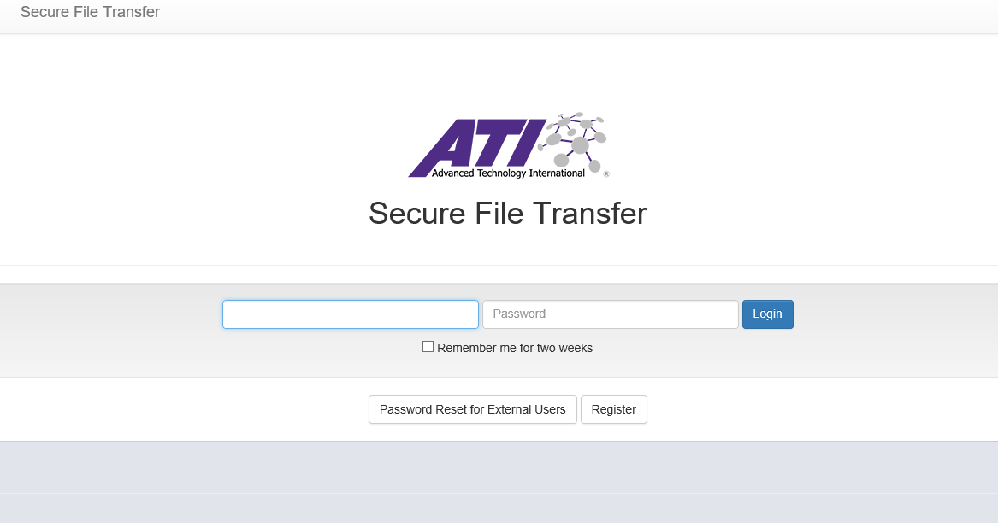

- This will open a new window:
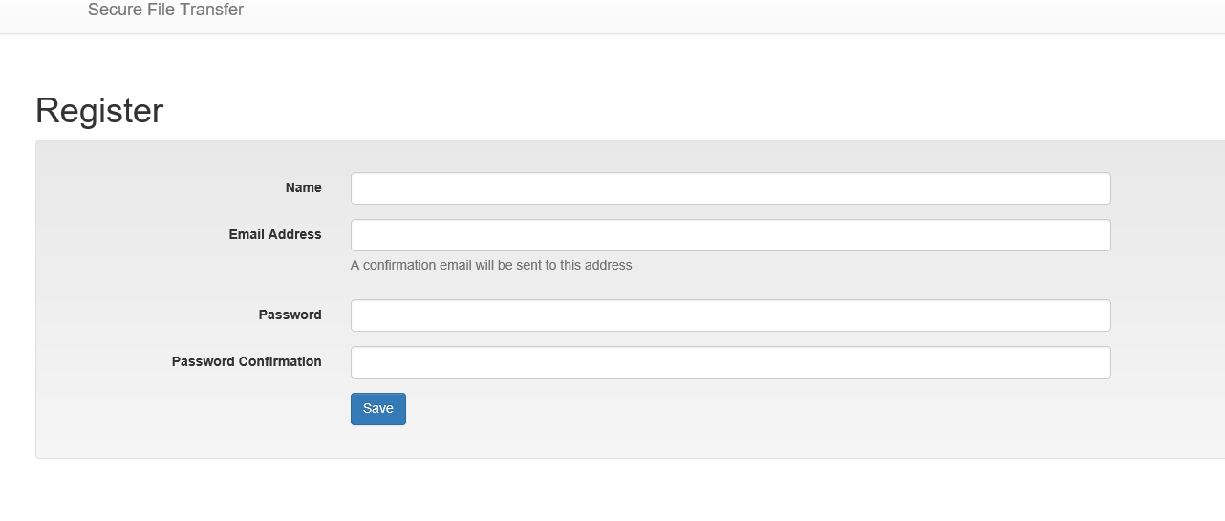
- Complete fields above

NOTE: it is recommended that offerors use their primary/work email address, to facilitate retrieval of relevant information. Also the site will prompt users to choose a strong password for increased security.

- Hit “Save”
- An email will be sent to the email address entered when registering, which will include a unique link to activate the account:
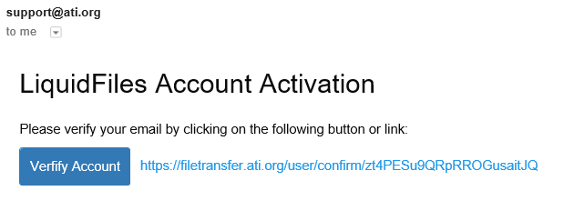

- Unique link will take you back to the Login Page to confirm email and password:
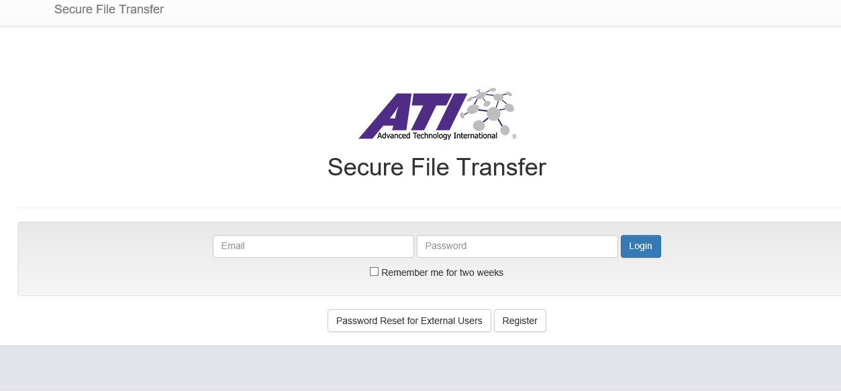

- Enter email and password used to register. Then hit “Sign In”

- Submitting Proposals
  - After signing onto the FTP Site, a message window will open:
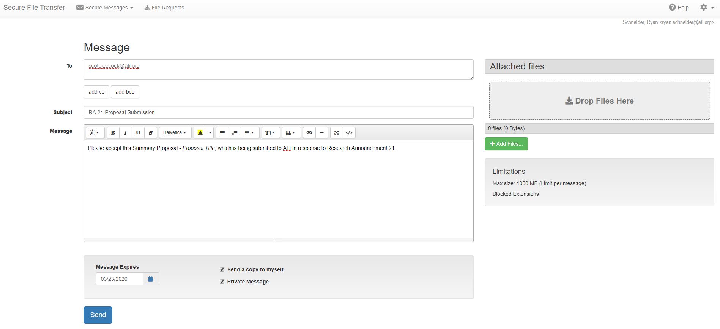
  - After completing the message as illustrated above and attaching your proposal files, offeror will hit “Send” Button.
  - Proposal will then be uploaded to the FTP site. A confirmation email will be sent to offeror that file has been successfully uploaded.
  - After ATI Point of Contact downloads proposal, offeror will be notified via email that proposal has been downloaded.

