Statement of Work Guide
for Research Announcement 21

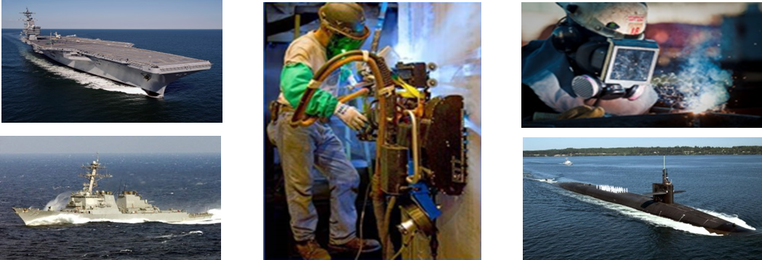

MISSION
- The mission of the National Shipbuilding Research Program (NSRP) is to reduce the total ownership cost and improve the capabilities of both United States Government and U. S.-flag commercial ships.
- The Program accomplishes this mission by providing a collaborative framework to manage, focus, develop, and share research and development and leverage best practices in shipbuilding and ship repair.

INTRODUCTION
The mandatory Statement of Work (SOW) developed by the offeror and submitted subsequent to selection of the Summary Proposal by the NSRP Executive Control Board will be incorporated into the binding agreement known as a Task Order Agreement. The SOW shall contain a summary description of the technical methodology as well as the task descriptions, but not in so much detail as to make the contract inflexible. The SOW shall not include any proprietary or company-sensitive information.

FORMAT
The following is the required format for the SOW.
- Scope: This section includes a statement of what the program covers. This should include the technology area to be investigated, the project’s objective and goals, and an overview of the work that will be accomplished by the project to accomplish the objectives and goals. It is also appropriate in this section to specify related work that will not be included in the project’s efforts (i.e. “out of scope”), but accomplished by other planned activities.
- Detailed Description of Tasks: Describe each task in detail. The tasks, which represent the work to be performed under the contract, will be considered binding upon contract award. Thus, they should be developed in an orderly progression and in enough detail to establish the feasibility of accomplishing the overall program objectives and goals. The work effort should be segregated into major tasks and identified in separately-numbered paragraphs, as in the example below. Any cost-shared work is to be included in the description of these tasks. Subtasks may be included in this description at the offeror’s discretion.
2.1 Task 1 – Title: (text providing overview of Task and relation to project objective)
2.1.1 Subtask (detailed description of activity)
2.1.2 Subtask (detailed description of activity)

2.2 Task 2 – Title: (text providing overview of Task and relation to project)
2.2.1 Subtask (detailed description of activity)
2.2.2 Subtask (detailed description of activity)

An option may be included in the SOW for additional activities after project completion to support the transfer of technology developed to industry. This option may be exercised during the contract period depending on funding availability and the merits of the project results. Inclusion of options in the SOW does not guarantee approval or funding from NSRP.

- Technical/Design Reviews: The contractor shall identify intended quarterly reviews, with intended attendees, and when and where they will be conducted.
- Deliverables: Results of the technical effort are contractually binding and shall be identified herein under the same Task/Subtask hierarchy developed in Section 2.0 above. Proposers are advised to read the Task Order Agreement carefully. Any and all hardware/software to be provided to the NSRP as a result of this program shall be identified. A Project Management Plan shall be included as a deliverable. If appropriate, a Software Development Plan shall also be included as a deliverable. (Both of these plan guides are available under ‘RA Project Plans and Templates’ at https://www.nsrp.org/project-plans-and-templates/.) Deliverables should be submitted in PDF or MS Office (98 or later) format. (A Technology Transfer & Implementation Plan will be required for submission at the same time as the Statement of Work and Cost Proposal.) Include this statement in the Deliverables section: “As part of the Final Report, Return on Investment (ROI) results will be detailed, to include addressing ROI differences between initial estimates and final results. The Final Report will also include a comparison between the beginning Technology Readiness Level (TRL) of the process or technology, the projected TRL at project completion, and the realized TRL at project completion.”
  - Phase Go/No go criteria: If there are multiple phases to the project, a phase Go/No go criteria deliverable is required, prior to start of next phase. Project phases can be no more than 12 months in length. For the Phase Go/No go decisions, include the criteria for that decision in this section. Phase Go/No go criteria must be specific and able to be verified by others outside of the project team (and especially by the Program Technical Representative). For example, criteria can include completion of certain tests or other project activities, or achieving certain measured parameters with the project’s prototype system. (An updated Technology Transfer and Implementation Plan (TTIP) is also required for the Phase Go/No Go determination—See the Technology Transfer and Implementation Guide (TTIG), which is available on the NSRP website.)
- Metrics/Benefit Realization: Indicate the performance improvement metrics that will be developed for the project, using the format in the table below. This presentation should correspond to the metrics information in the Summary Proposal. Except where clearly not practicable, performance improvement metrics shall be developed and tracked for all projects, to compare the “as-is” practice to that which is anticipated as project results are implemented. Actual benefits realized for the indicated metrics will be included in project reports. Include this sentence before the table: “Metrics will be reported in accordance with the intervals specified in the metrics table and procedures to be established by the Program Administrator.”
Metric | “As-Is” Baseline | Project Goal | Delta | % Change  (+/-) | Tracking & Reporting Plan
Ship repair cycle time | 120 days | 85 days | 35 days | -29% | Select a similar ship availability as baseline; document cycle time at the end of the job
Transaction cost for________ | $700 | $125 | $575 | -82% | Report quarterly as process improvements are implemented
Parts in inventory | 20,000 | 12,000 | 8,000 | -40% | Set a monthly part reduction goal & assess each month; report quarterly the reduction and any changes to the plan to reach project goal
Technology Readiness Level | 4–Component validation in laboratory environment | 5–Component validation in relevant environment |  |  | Demonstrate viability of lab-tested technology in shipyard production environment

Table #1 – Metrics/Benefits Realization

