Project Management Plan

Guidance & Template

MISSION

* Manage and focus national shipbuilding and ship repair research and development funding on technologies that will reduce the cost of ships to the U.S. Navy, other national security customers and the commercial sector, and develop and leverage best commercial and naval practices to improve the efficiency of the U.S. shipbuilding and ship repair industry.
* Provide a collaborative framework to improve shipbuilding-related technical and business processes.

# Introduction

A Project Management Plan **is required** for all Research Announcement projects and must be approved by the Program Technical Representative (PTR) upon submission to Advanced Technology International (ATI).

This guide has been created to assist project teams in developing a strong project management plan that reflects both the objectives of the project and the overall mission of the National Shipbuilding Research Program (NSRP).

This template includes essential elements of a well-composed project management plan, including team structure, activities schedule, milestone schedule, budget, as well as any associated plans --communications plan, risk management plan, software development plan (if applicable), and technology transfer and implementation plan **(required).**

Also included are templates for technical and business quarterly reports, which are to be submitted on a quarterly basis to ATI, who is responsible for reporting the status of current projects to the Navy. As noted in Article IX, Section D, Distribution Statement, of the Task Order Agreement, it a requirement that all data and reports be marked with a distribution statement to denote the extent of its availability for distribution, release, and disclosure without additional approvals or authorizations. It is important for project teams to become familiar with the Program distribution statements, which are included in the [Technology Transfer & Implementation Guide](https://www.nsrp.org/resource-library/).

In addition, there is a presentation template to be used for technology transfer activities.

**{TEMPLATE}**

National Shipbuilding Research Program

PROJECT MANAGEMENT PLAN

Name of Project

**TASK ORDER AGREEMENT #20XX-XX-XXX**

Project Lead Organization

Team Member Organization #1

Team Member Organization #2

Team Member Organization #3

Date of Submission

Table of Contents

Introduction 1

Project Management Plan 4

Technology Transfer Plan 8

Software Development Plan 8

Communication Plan 8

Attachment 1 – Project Team Contact Information 9

Attachment 2 – Communication Log 10

Attachment 3 – Quarterly Technical Report 11

Attachment 4 – Quarterly Business Report 13

Attachment 5 – Project Presentation 16

# Project Management Plan

*[Project Lead Organization]* plan for managing NSRP ASE Project Number 20XX-XX-XXX is laid out in the following sections. The Work Statement Summary provides a general overview of the work to be accomplished over the duration of the project. The Statement of Deliverables provides a description of the major deliverables to be submitted during the course of the project. The Payable Milestones Table describes the actual milestones to be paid.

## Project Team and Management Structure

The Project Team consists of *[Project Lead Organization (Acronym/Abbreviation)]* as the project lead, with *[other shipyards, design agents, software developers, educational institutions, industry experts]* as team members.

*[Provide brief background information on team members (i.e., why did the lead organization choose to work with these companies on the project; how are their credentials relevant to the achieving the objectives of this project]*

### Project Personnel Leads

|  |  |
| --- | --- |
| Team Member Organization | First Name Last Name |
| Team Member Organization | First Name Last Name |
| Team Member Organization | First Name Last Name |
| Team Member Organization | First Name Last Name |
| Team Member Organization | First Name Last Name |

### ATI Project Personnel

|  |  |
| --- | --- |
| Program Technical Representative (PTR) | First Name Last Name (Organization) |
| ATI Technical Manager (PM) | First Name Last Name (ATI) |

## Project Organization

This project will be organized in a “Lead – Team Member” format. In this type of structure, *[Lead Organization]* has signed the Task Order Agreement (TOA) and will be responsible for overall project and program management, including all interfaces with the NSRP program management staff. Each Team Member will be issued a Purchase Order/Subcontract Agreement, which will refer to the scope of work and agreed to costs in the TOA. All contractual flow-down requirements in the TOA will be applied to each individual Team Member. *[Lead Organization]* will also include a statement which clarifies that the Team Member agrees to work in collaboration with the other named members under the contractual provisions of the TOA. An organizational chart of the project management team is shown below:

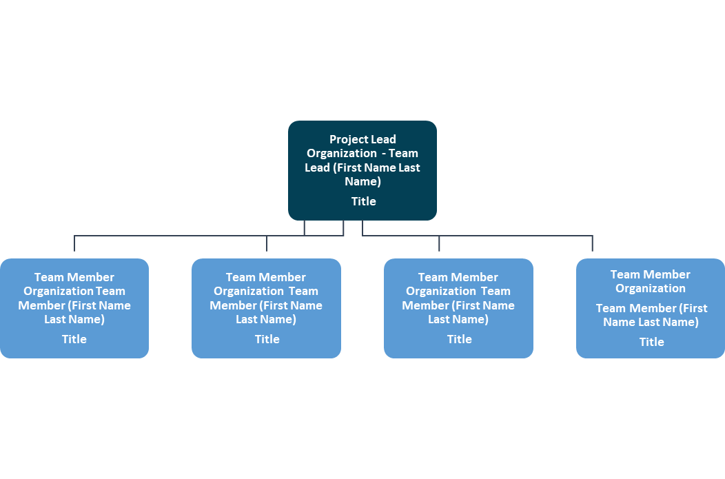

The technical team is comprised of experienced and diverse personnel, with collaborative involvement on many high profile NSRP projects in the past . . . . *[Provide a description of the capabilities of the project team and in meeting project objectives* *and responsibilities associated with each team can be further delineated in this section]*

## Schedule of Project Activities

This project intends to *[provide a short description of project with a bullet list of goals – examples below]*

1. Investigate . . . . .
2. Compare and collate . . .
3. Create and define . . . .
4. Demonstrate . . . .
5. Publish the final report . . .

### **Major Milestones for the Project**

### [it is recommended that project activities are divided by Phase]

|  |  |  |
| --- | --- | --- |
| Phase | Activity | Team Member Responsible |
| 1 | Definition of . . . | Project Team |
|  | Development of . . . | Team Member 1 |
| 2 | Development of . . . | Project Team |
|  | Demonstration of . . . | Team Member 1 and 2 |
|  | Final Product/tool/process | Project Team |

### **Technical Project Reviews**

As finalized at the Project Kickoff Meeting held at *[Organization/Facility – usually held at the facility of the Project Lead]* on *[Month Day, Year],* the following Technical Project Review Meetings have been outlined below:

|  |  |  |
| --- | --- | --- |
| Quarterly Review | Date | Location |
| Meeting | Date | Location |
| 1 | January 1, 20XX | Team Member 1 Facility |
| 2 | April 1, 20XX | Team Member 2 Facility |
| 3 | July 1, 20XX | Team Member 3 Facility |
| Final | October 1, 20XX | Team Member 4 Facility |

## Work to be Performed

*[Bulleted list of tasks and associated deliverables, Gantt charts, flow charts and other workflow diagrams can be used to illustrate work to be performed]*

### **Project Metrics**

Metrics will be reported in accordance with the intervals specified in the metrics table and procedures to be established by the Program Administrator.

*[Metrics table below is from the Project Technical Proposal]*

|  |  |  |  |
| --- | --- | --- | --- |
| **Metric** | **“As-Is” Baseline** | **Project Goal** | **Tracking & Reporting Plan** |
|  |  |  |  |
|  |  |  |  |
|  |  |  |  |
|  |  |  |  |

### **Project Budget and Milestone Schedule**

Below is the milestone payment schedule in accordance with TOA No. 20XX-XX-XXX. Each Team member will receive a similar attached payable milestone schedule where the dates have been adjusted (7-10 days earlier), to allow the Project Lead sufficient time to assemble team members’ supporting documents prior to deliverable submission date. Team members will also be provided with their discrete work scope and deliverable list that is aligned with their own specific payable milestones. Invoicing for milestone payments is planned per the payable milestone table below.

*[Include a budget summary table (by Phase) and/or milestone schedule from the Task Order Agreement (Attachment 3)]*

# Technology Transfer Plan

A Technology Transfer and Implementation Plan (TTIP) is a **required stand-alone document** for all RA projects and must be submitted prior to contract award. Please refer to the [Technology Transfer & Implementation Guide](https://www.nsrp.org/resource-library/) for additional information and requirements.

# Software Development Plan

*[If no Software Development Plan is required for this project, denote as such:* ***A Software Development Plan for the project is not required as no software will be developed as a result of this project.****]*

*[If a Software Development Plan is required for this project, please refer to the* [*Software Development Plan Guide*](https://www.nsrp.org/project-plans-and-templates/) *on the NSRP website]*

# Communication Plan

*[Although not a formal requirement, incorporating a Communication Plan within the Project Management Plan can serve as a guiding map for internal project team communications throughout the duration of the project. Communication Plans can include report templates, presentation templates, project team contact information, communications and project-specific website information.]*

In addition to quarterly project review meetings, team members should be in regular communication with one another, through informal discussions and emails, as well as regularly scheduled conference calls and interim meetings. The Project Technical Lead, the Program Technical Representative and the ATI Technical Manager should also engage in regular communications for interim updates.

The following materials can be included in the Communication Plan:

* Team Members Contact Information (Attachment 1)
* Communications Log (Attachment 2)
* Report Templates:
  + Quarterly Technical Report (Attachment 3)
  + Quarterly Business Report (Attachment 4)
  + Other Reports -- Formatting for other reports will be dictated by the milestones/deliverables being reported; i.e., demos, testing, development of tool or process)
* Presentation Template (Attachment 5)
* Project Website [if applicable] – *[Hyperlink]*

# Attachment 1 – Project Team Contact Information

|  |  |  |  |  |  |
| --- | --- | --- | --- | --- | --- |
| Name | Title | Organization | Project Role | Telephone | email |
|  |  |  |  |  |  |
|  |  |  |  |  |  |
|  |  |  |  |  |  |
|  |  |  |  |  |  |

# Attachment 2 – Communication Log

|  |  |  |  |  |
| --- | --- | --- | --- | --- |
| Date | Time | Team Members | Type of Communication | Issue-Related |
| 3/1/20XX | 3:00 PM | Project Lead, PTR, Project Team Member 1, ATI | email | No – interim status call |
| 4/6/20XX | 10:00 PM | Project Team | telephone | Yes – schedule slippage |
| 5/15/20XX | All Day | Project Lead, Team Member 1, Team Member 2, ATI | Quarterly review |  |

# Attachment 3 – Quarterly Technical Report

***[To be submitted to ATI by each March 20th, June 20th, September 20th and December 20th during the project period of performance]***

**QUARTERLY REPORT**

DATE _______________

**Section I**

**Technical Status Report**

**Task Order Agreement xxxx-xxx-xx**

**between**

**the Advanced Technology International**

**and**

**yyyyyyyy**

**for**

**(specific project name)**

**Project Overview**

**Provide a short description of the project and objectives being addressed.**

**Technical Progress**

This is the xxxx Technical Status report for the subject agreement. Technical efforts for the period ________ through _______ 20XX include:

* Continued xxxx
* Published yyyyy
* Held zzzzzzz
* Commenced aaaaaa

**Major Developments**

Describe key developments that have been achieved during this reporting period. Include short summaries of significant results that can be used for describing project accomplishments to a wide audience.

**Realized Benefits to Industry and Navy**

Provide a qualitative assessment of the benefits realized by the project lead, team members, and other non-participating industry members through technology transfer. A discussion on how the Navy has benefited from project execution should also be included. It is anticipated that once the project enters the implementation phase, quantitative returns will also be provided.

**Technology Transfer**

Describe activities/efforts that were accomplished during the reporting period to transfer technology beyond the project team members. These activities can include demonstrations, presentations, participation in symposia, etc.

**Plans for the Next Quarter**

Briefly list planned activities for the next period.

**Project Issues**

Briefly discuss any technical issues identified that may impact the current program progress. In addition to technical issues, list any subcontractors not under agreement or any subcontractor-related issues that may impact the current program progress.

**Schedule Issues**

Briefly discuss issues affecting the approved schedule and actions planned to adhere to the approved schedule.

**Cost Issues**

Briefly discuss issues that may impact the contracted amounts for program funding and cost share.

**Action Items**

Discuss the status of any action items established between the project team and the PTR.

**ROI Trend**

Referencing the Business Case/ROI discussion from the proposal or Technology Transfer & Implementation Plan, provide an indication of the ‘trend’ of that projection. The trend could be an “increase in potential cost impact” due to better-than-expected results during field testing; a “decrease in potential cost impact” based on pilot results; or “no change”.

**TRL Assessment**

If applicable, provide an assessment of the starting Technology Readiness Level (TRL) of the project’s technology or process, and the final TRL assuming a successful completion.

# Attachment 4 – Quarterly Business Report

***[To be submitted to ATI by each March 20th, June 20th, September 20th and December 20th during the project period of performance]***

**QUARTERLY REPORT**

**Section II**

**Business Status Report**

**Task Order Agreement xxxx-xxx-XX**

**between**

**the Advanced Technology International**

**and**

**yyyyyyyy**

**for**

**(specific project name)**

**Agreement Summary Information**

Total Amount of the Agreement: $

Total Estimated NSRP ASE Project Funding of the Agreement: $

Total Estimated Recipient Cost Share: $

Total Funds Obligated: $

**Project Resource/Cost Information:**

The following resources/costs are applicable to this project for the period ________ through _______ 20XX:

|  |  |  |  |  |  |
| --- | --- | --- | --- | --- | --- |
| **Company** | **Man Hours Provided This Period \*\*** | **Cumulative Man Hours Provided \*\*** | **Significant Material Costs This Period** | **Cumulative Material Costs** | **List of Personnel Working This Period** |
| Recipient |  |  |  |  |  |
| Team Member A |  |  |  |  |  |
| Subcontractor X |  |  |  |  |  |
|  |  |  |  |  |  |
|  |  |  |  |  |  |
| Total |  |  |  |  |  |

** As an alternate, actual costs (less material costs) may be provided in lieu of Man Hours

**Status of Milestones**

|  |  |  |
| --- | --- | --- |
| **Milestone**  **Number and Description** | **Percentage Completed During this Period** | **Cumulative Percentage Completed** |
| 1 – Design Document |  |  |
| 2 – etc |  |  |
| … |  |  |
| X- |  |  |

**Cost Share Provided by Project Participants**

Cost share in the amount of $_________ is provided for this reporting period. Cumulative cost share to date for the project is $_____________. The following summarizes the cumulative cost share provided for this project by category:



*IR&D matching funds should be identified separately and not included in the Overhead line

# Attachment 5 – Project Presentation

Please see template available on the NSRP website:

[Project Presentation Template](https://www.nsrp.org/project-team-materials/)